EVALUATION AND DRIVING MECHANISM ANALYSIS ON SATURATED OIL RESERVOIRS BY USING PETROLEUM EXPERTS SOFTWARE (MBAL)

THESIS

This Thesis is submitted as a Part of the Requirements to Obtain Bachelor Degree From Oil and Gas Department at Faculty of Energy and Mining Engineering At Sebha University

BY:

Abdul Wahid Said Ashpop

22110019

ADVISOR:

Eng.Mohammed Samba


Sebha University

2018/2019

EVALUATION AND DRIVING MECHANISM ANALYSIS ON SATURATED OIL RESERVOIRS BY USING PETROLEUM EXPERTS SOFTWARE (MBAL)

BY:

Abdul Wahid Said Ashpop
22110019

Major Subject: Oil and Gas Engineering

Sebha University

Approved By

Advisor,

Eng.Mohammed Samba

Date:

وَعَلّمَكَ مَاَ لَمْ تَكُن تَعْلم وَكَانَ فَضُلُ اللهِ عَلَيكَ عَظيِما

صدق الله العظيم

الآية{113}من ســــورة النساء.

ACKNOWLEDGEMENT

I would like to express my greatest appreciation to my supervisor Eng.Mohammed Samba
for their guidance, support and encouragements throughout my entire pacalories study.
Their meticulous attention to details, incisive but constructive criticisms and insightful comments have helped me shape the direction of this thesis in the form presented here, on. I am also thankful to them for their strong supports in other aspects of life than research. I would also like to convey my gratitude to the head of Material engineering department. I deeply appreciate my parents and my family. Their love and encouragement light up many lonely moments in my life as As a university student away from home and have been the source of courage when I was down. I would like to express my sincere thanks to all my friends and colleagues in the study. Their support, friendship and encouragement made my pacalories study a journey of happiness.
Last, but not least, I am grateful to every individual who has helped me in one way or another during my bachelor's study.

Abdul Wahid Said Ashpop

ABSTRACT

The l fild was selected to be the subject of a reservoir study in this project l field is one of the fields located in the sirt basin and owned by the Arabic gulf company of Libya
The main aim of mry work is to determine the quantity of oil in place using (MBAL)software and evaluate the drive mechanism for this reservoir . the study includes maps . figures , tables ,and a report outlining the results.

The results have shown that software petroleum experts (MPAL) the reservoir engineer ean interpret and predict the well production and efficiency of the reservoir, and know the measures used to improve the increase rate of production.

In this report, we explain how the engineer conducts reservoir behavior and his ability to predict future production with the type of reservoir and its mechanism by using software petroleum expert (MBAL) .

Oil symbols
No | Item | Name
 | T | Temperature
 | V | Volume
 | m | Mass
 | $$ρ$$ | Density
 | $$γ_{0}$$ | Viscosity of the oil
 | $$ρ_{w}$$ | Density of the water
 | $$ρ_{0}$$ | Density of the oil
 | $$C_{0}$$ | Oil compressibility
 | $$V_{g}$$ | Volume of the gas
 | $$V_{g}$$ | Volume of the oil
 | $$P_{atm}$$ | Pressure at atmospheric pressure
 | $$B_{0}$$ | Oil formation volume factor
 | $$R_{s}$$ | Solution gas oil ratio
 | FvF | Formation volume factor

vi



No | Subject | Page
 | Acknowledgements | 1
 | List of Contents | II
 | List of Tables | III
 | List of Figures | IV
 | Abstract
 | ` Chapter One - Introduction
1.1 | Introduction | 2
1.2 | Research Objective | 4
Chapter 2 Literature Review About Drive Mechanisms
2.1 | Reservoir Drive Mechanisms | 6
2.1.1 | Solution Gas Drive | 6
2.1.2 | Gas Cap Drive | 7
2.1.3 | Water Drive | 8
2.1.4 | Gravity Drainage Drive Mechanism | 9
2.1.5 | Combination Drive | 10
2.2 | Types of Reservoir | 11
2.2.1 | Under saturated Oil Reservoir | 11
2.2.2 | Saturated Oil Reservoir | 12
2.3 | Reservoir Energy | 14
2.4 | Reservoir Pressure | 15
2.5 | Sources of Reservoir Energy | 15
 | Chapter 3. Literature Review About PVT
3.1 | Introduction | 18
3.2 | PVT analysis | 18
3.3 | PVT Analysis Applications | 18
3.4 | PVT parameters | 19
3.4.1 | Bubble Point Pressure | 19
3.4.2 | Viscosity | 19
3.4.3 | Formation Volume Factor | 19
3.4.4 | Solution Gas Oil Ratio | 20
Chapter 4. METHODOLOGY & PROCEDURES
1.4 | Background | 23
2.4 | Introduction | 23
4.3 | MBAL Graphical Interface | 23
4.4 | When MBAL is Started | 23
4.5 | The Various Tools Available In MBAL Are | 23
4.5.1 | Fractional Flow | 24
4.6 | Compositional Lumping/Depluming | 24
4.6.1 | Production History | 24
4.6.2 | Material Balance Tool | 24
4.6.3 | Material Balance Tool | 24
CHAPTER 4 FIELD INFORMATION
4.7 | Dedication | 27
CHAPTER 4. Methodology and Procedures
4.8 | Methodology | 29
CHAPTER 5. RESULTS AND DISCUSSION
5.1 | Tank and Reservoir Data | 31
5.2 | Water Production | 32
5.3 | Discussion of Calculation | 34
CHAPTER 6 Recommendations & conclusion
6.1 | Conclusion | 42
8.2 | Recommendations | 42
 | References | 43


N/F | Figure | Page
A | Location of Sarir field | VII
1.1 | Types of oil reservoir | 4
2.1 | Different Types Of Drive Mechanism | 6
2.2 | Solution Gas Drive | 6
2.3 | Gas Cap Drive | 7
2.4 | Water Drive | 9
2.5 | Water Coning | 9
2.6 | Gravity Drainage Drive Mechanism. | 9
2.7 | Combination Drive Mechanism | 10
2.8 | Compares Typical Production Decline Curves For The Different Drive | 10
2.9 | Under saturated Oil Reservoir With bottom Water Drive Reservoir | 11
2.10 | Under saturated Oil Reservoir With bottom Water Drive Reservoir | 12
2.11 | Saturated Oil Reservoir With Depletion Driver Reservoir | 13
2.12 | Saturated Oil Reservoir With Gas Cap Drive Reservoir | 13
2.13 | Saturated Oil Reservoir With Bottom Water Drive Reservoir | 14
2.14 | Saturated Oil Reservoir With Combination Drive Reservoir | 14
2.15 | Reservoir Pressure Depleted A after Production | 15
3.1 | Oil Formatiom Volume Factor Curve | 19
3.2 | Solution Gas Oil Ratio Curve | 20
4.7 | Location of Aswad well | 27
5.1 | curve water production and production simulation by carter model | 32
5.2 | carve phase saturation(fraction) and relative permeability by MODEL: Carter-Tracy | 32
5.3 | Energy Plot | 33
5.4 | Production Prediction | 33
5.5 | Oil-Black Data Input | 34
5.6 | Oil-Automatic calculation | 35
5.7 | water FVF with pressure | 35
5.8 | water viscosity with pressure | 36
5.9 | water density with pressure | 36
5.10 | water density with pressure | 37
5.11 | gas oil ratio with pressure Not When the pressure decreasing the gas while be free from the oil. | 37
5.12 | bubble point with pressure | 38
5.13 | Oil FVF With Pressure | 38
5.14 | oil viscosity with pressure | 39
5.15 | gas FVF with pressure | 39
5.16 | gas viscosity with pressure | 40



 | Table |  | Page
1 | Tank Data: Tank Parameter | 23
2 | Tank Data: Water Influx | 23

Chapter 1
Introduction

1.1 INTRODUCTION
Crude oil, natural gas, and water are the substances that are of chief concern to petroleum engineers. Although these substances sometimes occur as solids or semisolids, usually at lower temperatures and pressures, as paraffin, gas-hydrates, ices, or high pour-point crude's, in the ground and in the wells they occur mainly as fluids, either in the vapor (gaseous) or in the liquid phase or, quite commonly, both. Even where solid materials are used, as in drilling, cementing, and fracturing, they are handled as fluids or slurries. The division of the well and reservoir fluids between the liquid and vapor phases depends mainly on the temperature and pressure.^{[1]}
The state or phase of a fluid in the reservoir usually changes with pressure, the temperature remaining substantially constant. In many cases the state or phase in the reservoir is quite unrelated to the state of the fluid when it is produced at the surface. The precise knowledge of the behavior of crude oil, natural gas, and water, singly or in combination, under static conditions or in motion in the reservoir rock and in pipes and under changing temperature and pressure, is the main concern of oil and gas in the reservoir. ^{[3]}
Oil and gas accumulation occur in underground traps formed by structural and\or stratigraphic features. Fortunately they usually occur in the more porous and permeable portions of beds, which are mainly sands, sandstones, lime stones, and dolomites, in the intergranular openings, or in pore spaces caused by joints, fractures, and solution activity.
000 through the aquifer. In some cases the entire trap is filled with oil or gas, and in this case the trap and the reservoir are the same.
Under initial reservoir condition, the hydrocarbon fluids are in either a singlephase or a two-phase state. The single phase may be a liquid phase in which all gas present is dissolved in the oil. There are therefore dissolved natural gas reservoirs well as crude oil reservoir to be estimated. On the other hand, the single phase may be a gas phase. If there are hydrocarbons vaporized in this gas phase that are recoverable as natural gas liquids on the surface, the reservoir is called gas-condensate, or gas-distillate (the older name). In this case there are associated liquid (condensate or distillate) reservoirs well as the gas reservoir to be estimated. Where the accumulation is in two-phase state, the vapor phase is called the gas cap and the underlying liquid phase , the term improved recovery was introduction and has become popular in referring to, in general , any reconvert process that improves the recovery over what natural reservoir energy would be expected to yield. ^{[2]}
Types of oil reservoir

aturated reservoir

Under saturated reservoir

Without water
driver
reservoir

Bottom water
drive reservoir

Depletion

Drive

Reservoir

Gas

Cap Reservoir

Bottom

Water
Drive

Reservoir

Combination

Drive

Reservoir

Figure 1.1. Type of Oil Reservoir (REF)

1.2 Research Objective
- Calculate pressure in the reservoir by using the MABL program.
- Calculate change reservoir pressure and cumulative oil production with time.
- Calculate the original oil in place.
- Identify the type of driving mechanism.

Chapter 2
Literature Review About Drive Mechanisms

Chapter 2. Literature Review About Drive Mechanisms

2.1 Reservoir Drive Mechanisms
- Solution gas drive
- Gas cap drive
- Water drive
- Gravity drainage drive
- Combination drive

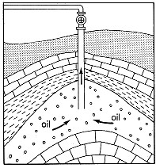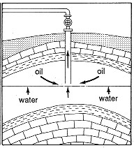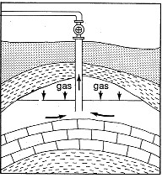

Figure 2.1. Different Types Of Drive Mechanism

2.1.1 Solution Gas Drive
The source of pressure is principally the liberation and expansion of gas from the oil as pressure is reduced with no attempt to maintain pressure by fluid injection.
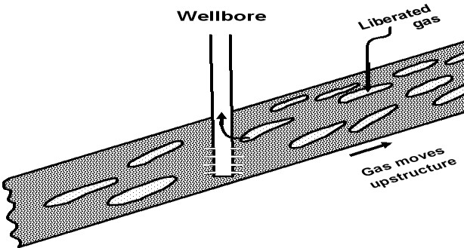

Figure 2.2.
Solution Gas Drive
.

The Most Common Mechanism of Solution Gas Drive Reservoirs are as the Following:
- The gas comes out of solution and pushes the oil up the tubing to surface
- The gas-oil ratio peaks rapidly, and then declines rapidly
- Therefore primary oil recovery is relatively low
- Primary recovery is where nothing is done to boost production by other means, such as gas or water injection
- The primary force to drive out the hydrocarbon is from within the reservoir itself

2.1.2 Gas Cap Drive
- A gas cap-drive reservoir uses principally the expansion of a cap of free gas over the oil zone
- In a gas-cap drive reservoir, pressure declines less rapidly, generally there is a larger volume of gas available than in a dissolved gas reservoir .
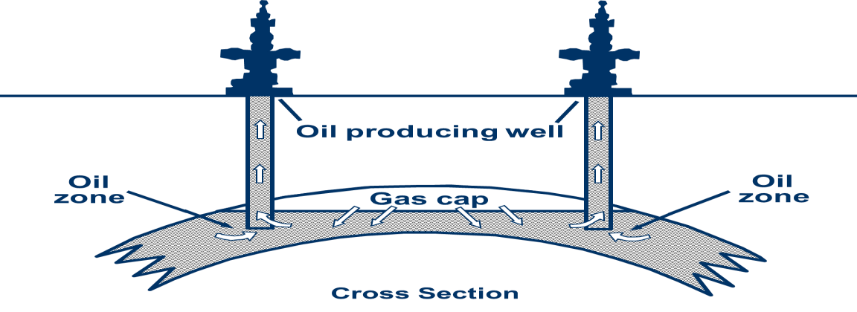

Figure 2.3. Gas Cap Drive.

2.1.3 Water Drive
- Principally an expansion or influx of water from outside and below the reservoir.
- In a water drive reservoir, pressure remains relatively high.
- Gas-oil ratios are low; but the well will eventually produce water (water breakthrough or water coning). This must be controlled by re-completion or shutting in of these wells. Re-completion is where the design of the well is altered0 so that water is not produced, this involves re-perforating further up the well bore, the use of packers, running a new liner.^{[4]}
- Eventually the well will produce significant amounts of water in order to maximize oil recovery; because the two liquids are mixed

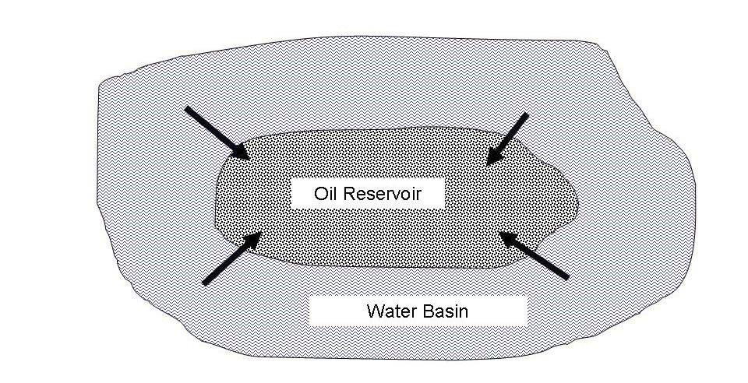

Figure 2.4.
Water Drive
.

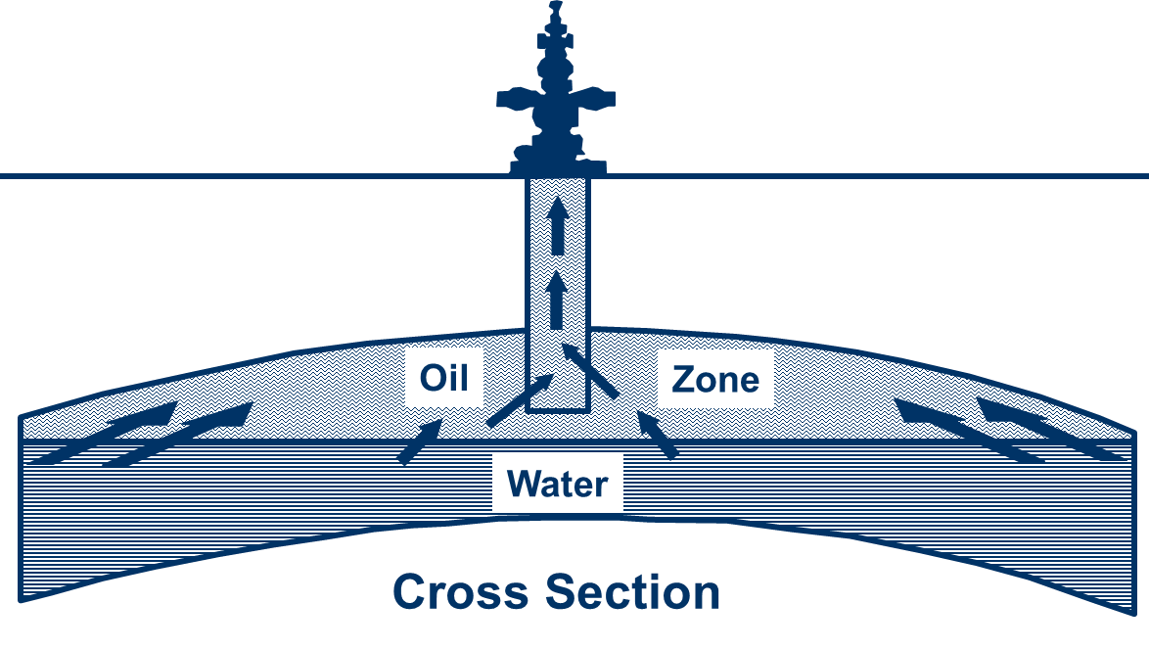

Figure
2.5.

Water
Coning
.

2.1.4 Gravity Drainage Drive Mechanism
- Gravity drainage may occur in any type of reservoir.
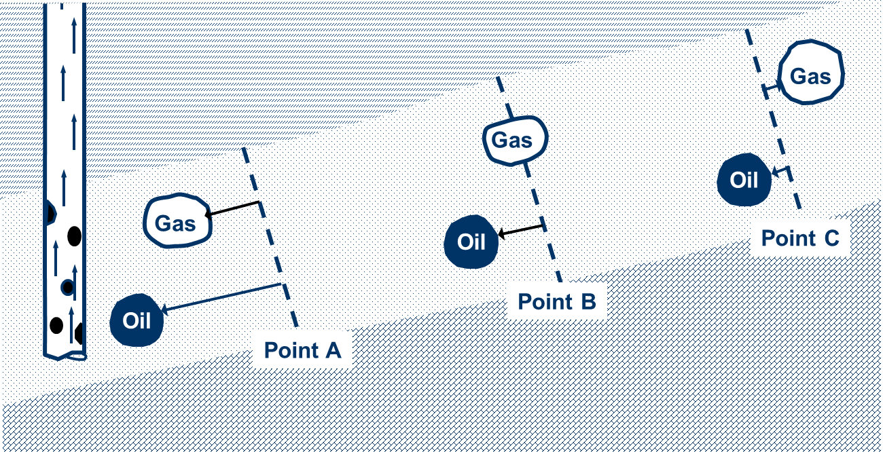
- Gravity drainage is particularly important in solution-gas and gas-cap drive oil reservoirs.

Figure 2.6. Gravity Drainage Drive Mechanism.
2.1.5 Combination Drive
- Basic drive mechanisms usually occur in combination.
- A large aquifer and a large gas cap can occur in a reservoir simultaneously.
- Oil production pressure drop results in some dissolved gas drive component in any oil reservoir drive mechanism.
- Even in water-drive and gas-cap drive.
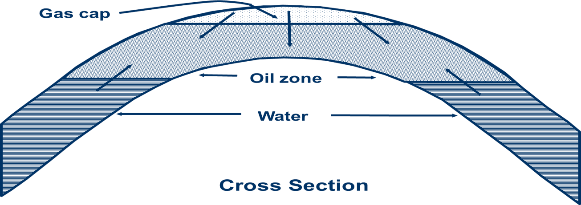

Figure 2.7. Combination Drive Mechanism.
The drive mechanism has different potential based on it is type, the following figure shown the effect of drive based on it is type
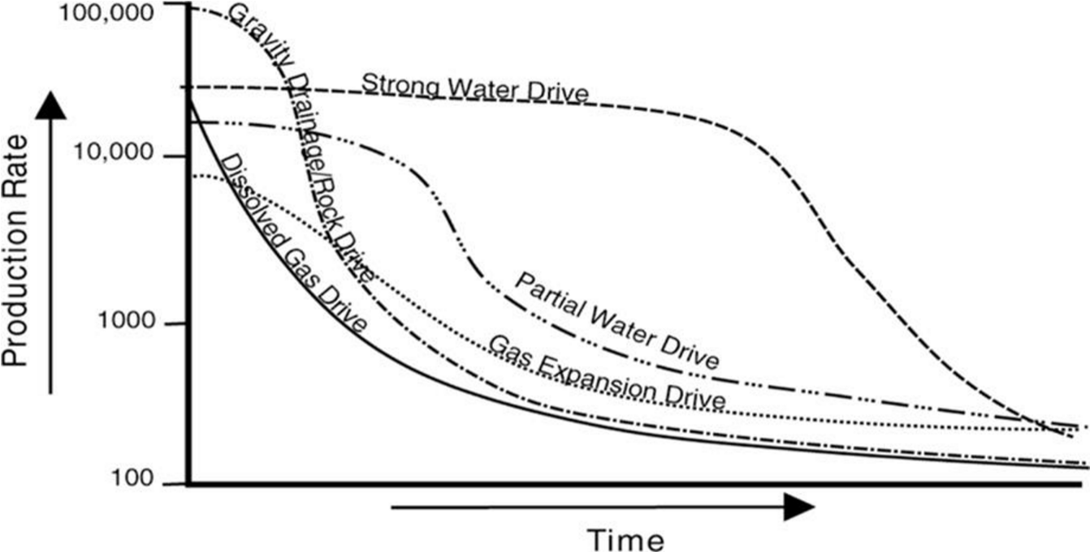
Figure
2.8

:

Compares Typical Production Decline Curves For The Different Drive Mechanisms

Described Above For A Reservoir With Approximately The Same Pore Volume. It Assumes All Other Factors Are Normalized.

2.2 Types of Reservoir

2.2.1 Under saturated Oil Reservoir
Under saturated Oil Reservoir including discrimination is initial pressure large than pressure bubble point , there is not free gas , the production by formation compressibility oil compressibility and water compressibility , when decrease pressure in the reservoir to less than from bubble point pressure change to saturated reservoir. Divided the under saturated Oil Reservoir to:

a) Without Water Drive Reservoir
This type also called under saturated Oil Reservoir that of size fixed the production in the type is effect extended existing fluid in the reservoir as shown in the figure (2.9).

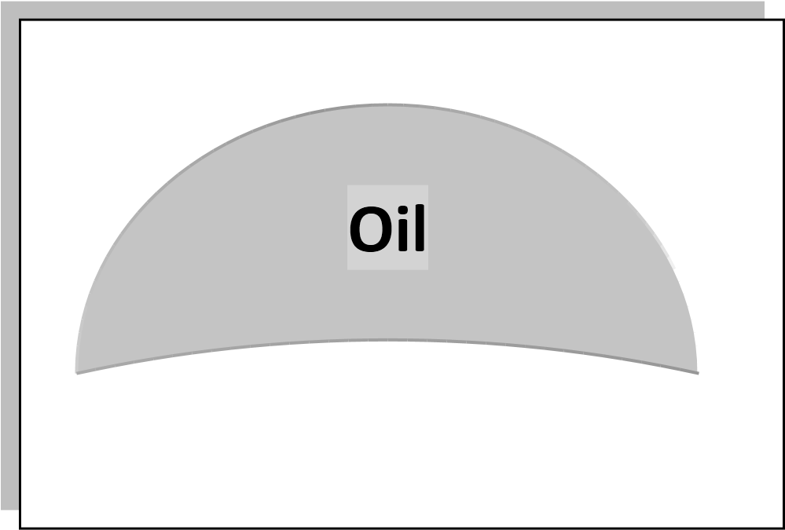

Figure 2.9. Under saturated Oil Reservoir without Water Drive Reservoir

b) Bottom Water Drive Reservoir
It the type include on layer from water in the down , the value of oil withdrawals from reservoir are replaced by water encroaching into oil zone as shown in Figure
2.10.
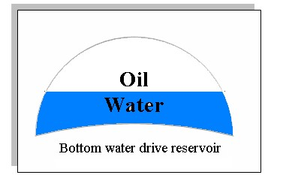
Figure 2.10. Under saturated Oil Reservoir With bottom Water Drive Reservoir.

2.2.2 Saturated Oil Reservoir
Saturated Oil Reservoir included discrimination is initial pressure less than saturation pressure and included free gas. Divide to four types from reservoir.

a) Depletion Driver Reservoir
The production in this type of reservoir the principal source of energy is a result of gas liberation from the crude expansion of the solution gas as the reservoir pressure is reduced .as pressure falls below the bubble point pressure gas bubbles are liberated within the microscopic pore space these bubbles expand and force the crude oil out of the pore space as shown in the figure (2.11).

b) Gas Cap Drive Reservoir
Gas cap drive reservoir can be identified by the pressure of a gas cap with little or no water drive. Due to the ability of the gas cap to expand, these reservoirs are characterized by sallow decline in the reservoir pressure. The natural energy available to produce the crude oil comes from the following two source:
Expansion of the gas cap gas or Expansion of the solution gas it is liberated.

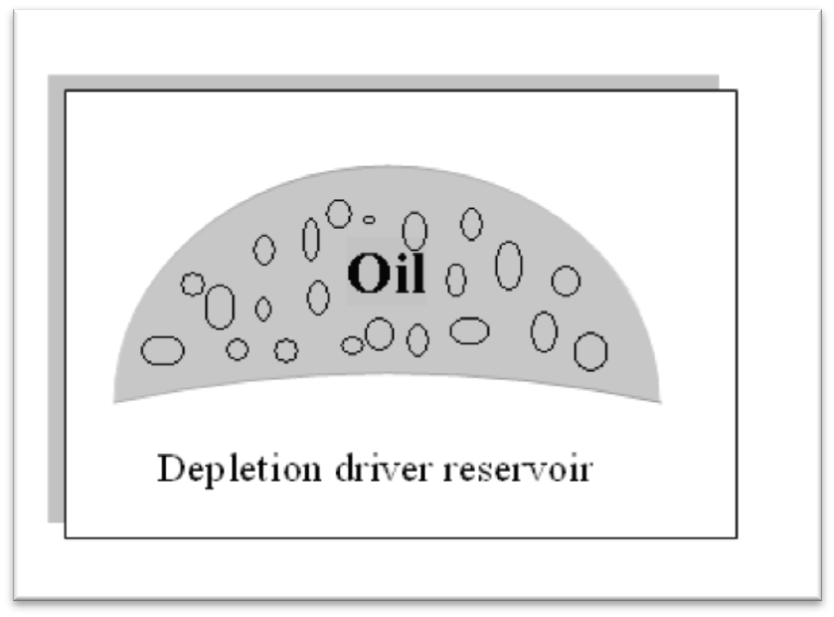
Figure 2.11. Saturated Oil Reservoir With Depletion Driver Reservoir.
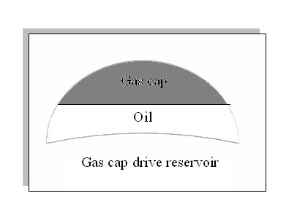
Figure 2.12. Saturated Oil Reservoir With Gas Cap Drive Reservoir.

c) Bottom Water Drive Reservoir :
For water drive reservoir with no gas cap, the MBE as straight line by technique of Odeh and Havlena. Tarner Suggests to predicate new pressure and water influx as a function of oil production (Np) and water production (Wp) as shown in the figure 2.13.

Figure 2.13. Saturated Oil Reservoir With Bottom Water Drive Reservoir.

d) Combination Drive Reservoir :
Two combination of driving forces can be present in combination drive reservoir as shown in figure ( 2.14 ):
• Depletion drive and water drive. • Depletion drive with gas cap and
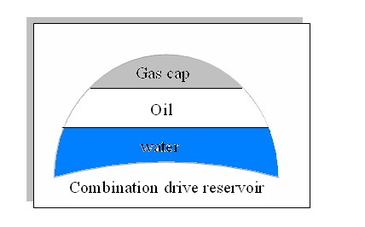
•

Water drive.

Figure 2.
14
.

Saturated Oil Reservoir With
Combination
Drive Reservoir
.

2.3 Reservoir Energy :
- Movement of gas and liquid in a reservoir can be compared to the movement of kind of matter.
- Gas and liquid are moved by energy in a reservoir
- The reservoir energy is a result of pressure differences, from a high pressure to a low pressure area
- Reservoir energy can be form an external source, water injection .

2.4 Reservoir Pressure
- The presence of high pressure alone will not cause movement of fluids.
- It also requires a low pressure area, a wellbore is drilled and becomes the low pressure area.
- If there is a path for flow, fluids move to the wellbore
- The flow rate is related to the pressure difference, the geometry of the wellbore and reservoir, and it’s permeability
- It would take a few thousand psi to force water through a household brick at the same rate that water flows through a garden hose .^{[5]}

2.5 Sources of Reservoir Energy
- Reservoir energy does not magically appear.
- For millions of years energy was stored from sources external to the reservoir.
- All energy in a reservoir comes from the earth.
- One energy form was gravity, causes compression.
- Overburden pressure,
- Another form was temperature of the earth.
- The conditions under which petroleum was created.
- In an oil reservoir, primary production results from the utilization of existing pressure.
- Basically, as has mentioned there are three drive mechanisms: solution gas, gas cap and water drive.
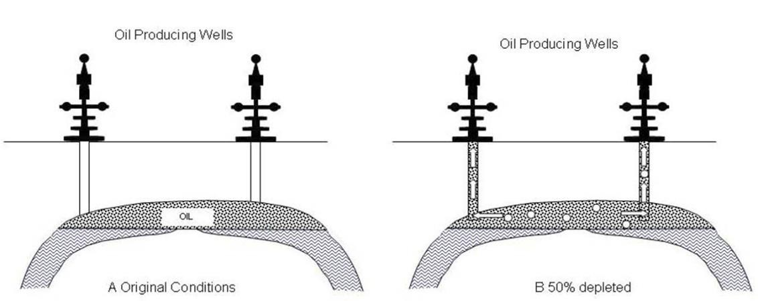

Figure
2.
16
.

Reservoir Pressure Depleted A
after Production

Chapter 3.

Literature Review About
PVT

Chapter 3. Literature Review About PVT

3.1 Introduction
Most reservoir calculations require PVT properties at reservoir temperature. Production engineers use phase behaviour data for surface separator design and to calculate flow in pipe, where such calculations are made over a range of temperatures from surface to reservoir conditions.

3.2 PVT analysis:
- PVT analysis determine oil and gas characteristics as a function of pressure, volume and temperature.
- PVT analysis are designed to study and quantify the properties of reservoir fluids at simulated recovery conditions.
- Using oil sampled, we can get properties of reservoir fluid such (Pb), (GOR),
(Bo), (ρ_{o})……etc.
- Study in the laboratory of the characteristics of the reservoir fluid, is called PVT analysis.

3.3 PVT Analysis Applications:
- Reservoir calculations.
- Well flow calculations • Surface facilities.
- Chemical composition of the reservoir fluid.
- Fluid volumetric behavior, to estimate reservoir depletion at constant temperature and production process from the tubing to surface facilities.
- Oil and Gas reserves, recovery factor and field development programs.

3.4 PVT parameters

3.4.1 Bubble Point Pressure
As pressure is decrease the liquid expands until the pressure reaches a point at which a few molecules are able to leave the liquid and from a small bubble of gas (this is the bubble point).

3.4.2 Viscosity
The viscosity is a measure of the resistance to flow exerted by a fluid. Viscosity of oil usually has units of centipoise.

3.4.3 Formation Volume Factor
If a volume of reservoir oil is flashed to stank tank oil conditions, a large amount of gas is released , and certain volume of oil is collected in the stock tank, both measured at standard conditions.

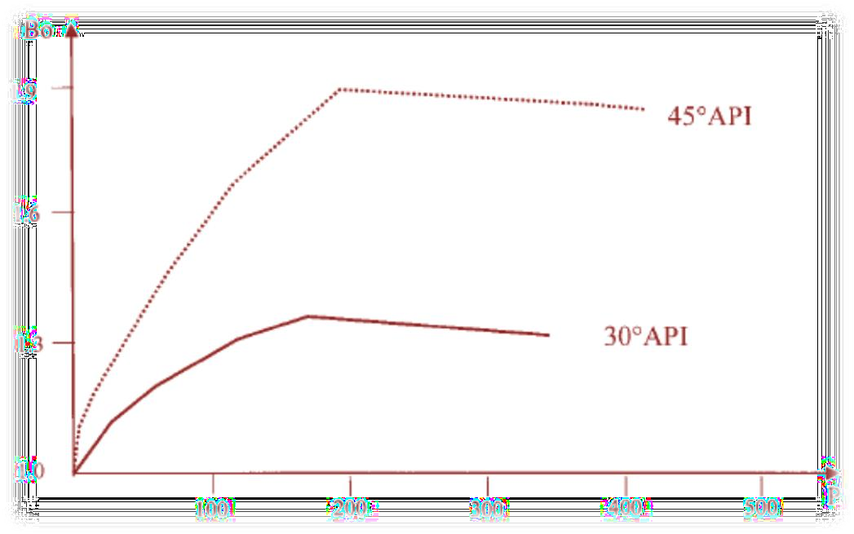Figure 3.1 : Oil Formatiom Volume Factor Curve
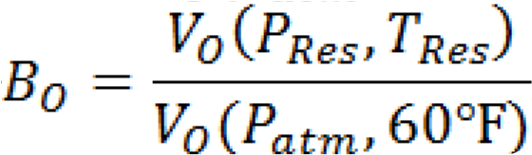

3.4.4 Solution Gas Oil Ratio
Referring to the previous experiment, the Gas Oil Ratio, is the ratio between the volume of gas dissolved (measured at standard conditions) and the volume of oil at standard conditions
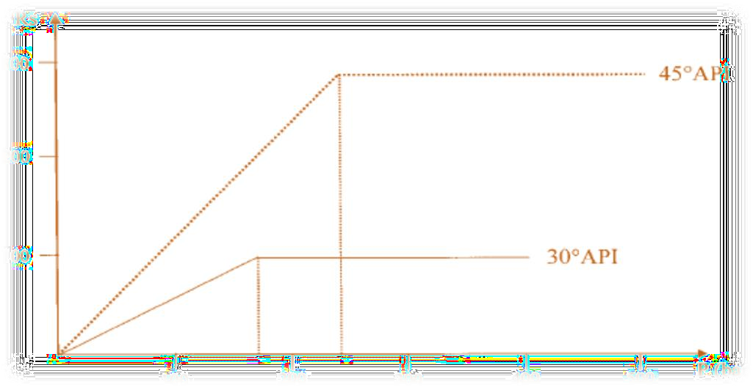

Figure 3.2. Solution Gas Oil Ratio Curve.

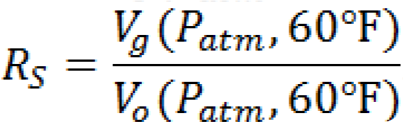

3.4.5 Isothermal Compressibility
Oil compressibility varies slightly with pressure and its value depends mainly on the oil and its gas content.

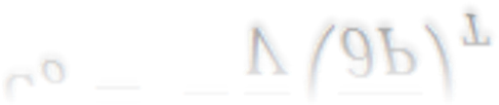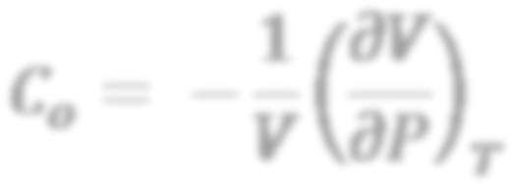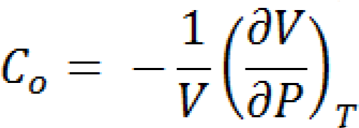

3.4.6

Crude Oil Density

The crude oil density is defined as the mass of a unit volume of the crude at a specified pressure and temperature, mass/volume

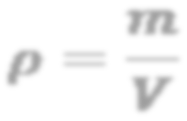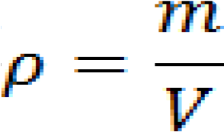

3.4.7 Specific Gravity (SG)
The specific gravity of a crude oil is defined as the ratio of the density of the oil to that of water. Both densities are measured at 60°F and atmospheric pressure.
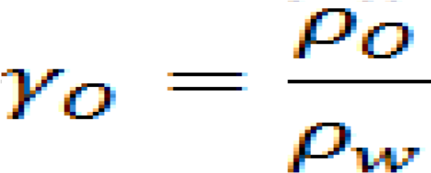

Chapter 4.
METHODOLOGY & PROCEDURES

Chapter 4. Literature Review About MBAL

4.1 Background
The natural energy of a reservoir can be used to move oil and gas toward the wellbore. Used in such a fashion, these sources of energy are called drive mechanisms. Early determination and characterization of the drive mechanism present within a reservoir may allow a greater ultimate recovery of hydrocarbons. Drive mechanisms are determined by the analysis of historical production data, primarily reservoir pressure data and fluid production ratios.

4.2 Introduction
This user guide gives an introduction to the key features available in the MBAL program developed by petroleum experts, MBAL is in a package made up of various tools designed to help the engineer to a better understanding of reservoir behavior and perform prediction run.

4.3 MBAL Graphical Interface :-
This version of MBAL now uses a graphical interface to facilitate the modeling of the reservoir. The new interface simplifies the task of building a model by allowing the user to sketch the various components of the reservoir. All the reservoir components such as tanks, wells and transmissibility (communication between tanks) are represented by unique graphical objects which may be easily manipulated on the screen. As components are added, the relevant input screens and fields are displayed prompting for the appropriate data to be entered.

4.4 When MBAL is Started:
The program automatically opens the last file accessed. Data files can be opened at any time during the current working session. If changes have been made to the current open file, the program will prompt to save the changes before opening a new file.

4.5 The Various Tools Available In MBAL Are:
- Material balance
- Reservoir allocation
- Monte Carlo volumetric
- Decline curve analysis
- Multi-layer

4.5.1 Fractional Flow
- Fractional flow instead of relative permeability curves
- Control of regression variables for fractional flow matching.

4.6 Compositional Lumping/Depluming

4.6.1 Production History
Import multiple well
- Entry of production history by month or year.
- Undo facility in history matching
- Plotting of prediction well rates against history well rates.

4.6.2 Miscellaneous
- Handle gas-lift curves with casing head pressure
- Ability to change units in dialog
- Allow edit/view of well relative permeability (prior to import to GAP) 4- Plot IPR with and without gravel pack.

4.6.3 Material Balance Tool
- Correct IPR for the effect of gravel pack
- Prediction based on Production Schedule for Multi-tanks
- Extend prediction type 1 (from production schedule) to multi-tank cases
- Prediction to Calculate Minimum Number of Wells to achieve Target Rate
- Improvements to Production History Input
- Enter comment for each history point and display on plots 7- Display weighting in production history dialogue.

The program displays the change in the distribution of the injected phase saturation. Each curve represents a distribution of saturations for a given pore volume injected (indicated on the plots as PV injected).
The calculation can be stopped at any time by clicking the Abort button. If the calculations are not stopped, the program ends the simulation at the cut-off value entered in the 'Reservoir and Fluids Parameters' dialogue box.
Input parameters can be accessed throughout the Input menu option. When changes to the input parameters are completed, press Calculate to start a new simulation

CHAPTER 4.

FIELD INFORMATION

4.7 Dedication

Name well : Aswad wells
Location: Sirt basin
Producing the well: crud oil with ration over 75%
This the well follows Gulf Arabic company beging in producing in years 1985 & continuous in the producing to this time, the figure 5.1 show the location of Aswad well.
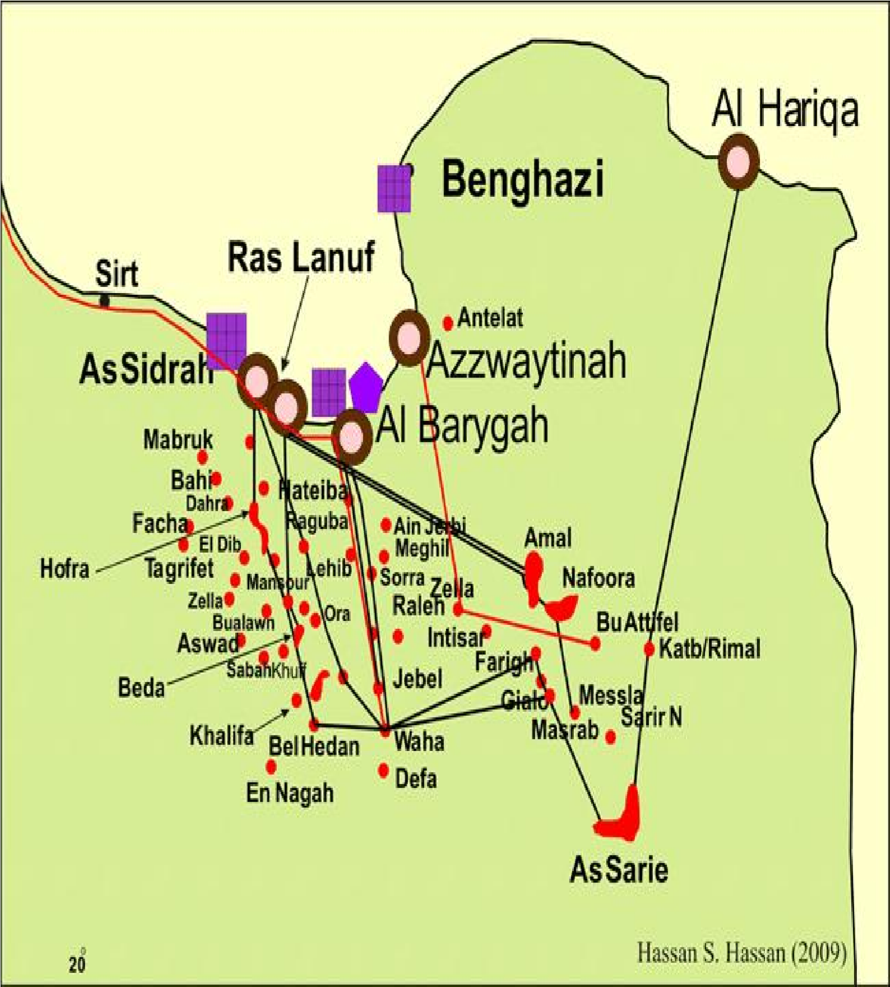
Figure 5.1: Location of Aswad well

CHAPTER 4.
Methodology and Procedures

4.8 Methodology
In order to accomplish the proposed objectives, Mbal simulator is used to run the Simulations to calculate the main objective. The main methodology of this research can be briefly mentioned as following :
- Collect the data from L field – Sirt Basin.
- Understand the mechanism of MBAL and how is it work .
- Arrange the data based on requirements of MBAL Software.
- Input the data to MBAL Software.
- Investigate and analysis the results.

CHAPTER 5.
RESULTS AND DISCUSSION

Chapter 7. Procedures and Results

This Chapter is describing the methodology and calculations that done depend on the objective of this research to explain how to calculate.

5.1 Tank and Reservoir Data

Table 5.1 : Tank Data: Tank Parameter.
 | Properties | Value/type | Units
1 | Tank type | Oil | /
2 | Name | Well Aswad | /
3 | Temperature | 100 | deg F
4 | Initial Pressure | 258 | Psig
5 | Porosity | 0.0121205 | fraction
6 | Connate Water Saturation | 0.31 | fraction
7 | Water Compressibility | 2.8e-6 | 1/psi
8 | Initial Gas Cap | 0
9 | Original Oil in Place | 13.9291 | MMSTB
10 | Start of Production | 31/03/1985 | Date m/d/y

Table 5.2 : Tank Data: Water Influx

Model/ Carter-Tracy
No | Properties | Value/Type | Unit
1 | Reservoir Thickness | 4.66559 | ft
2 | Reservoir Radius | 10.02 | ft
3 | Encroachment Angle | 2.09951 | degrees
4 | Aquifer permeability | 200 | Md

5.2 Water Production
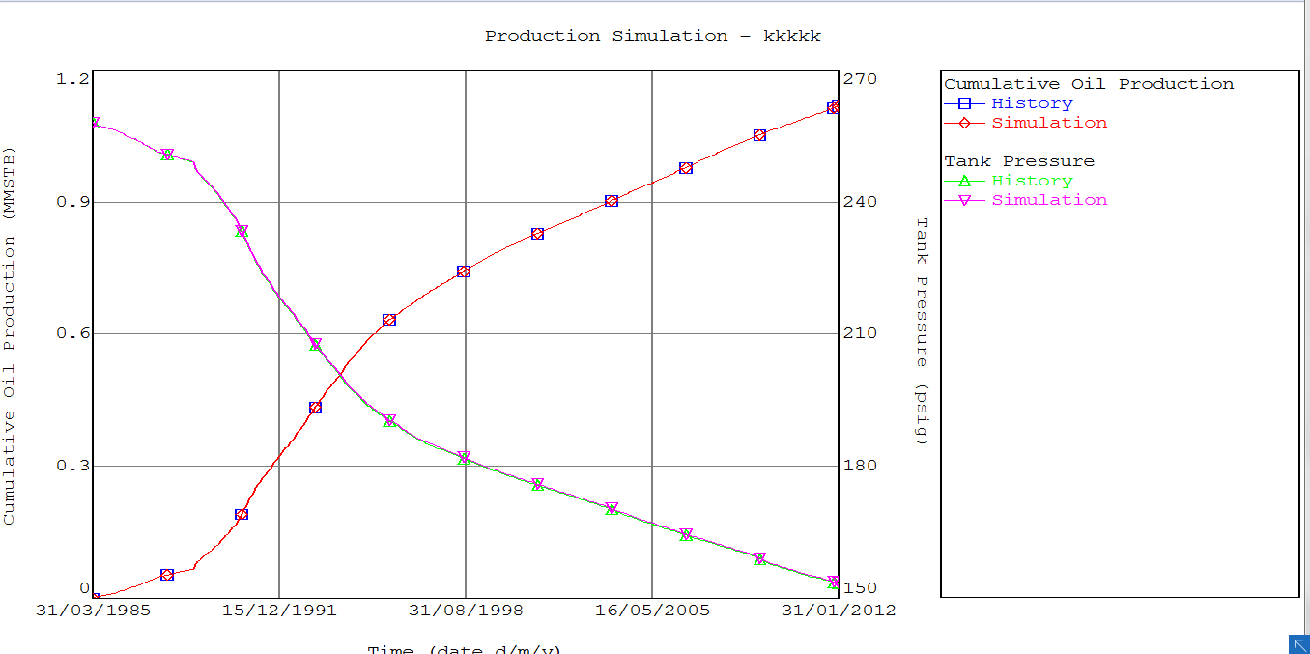
curve water production and production simulation by carter model Figure (5.1) :

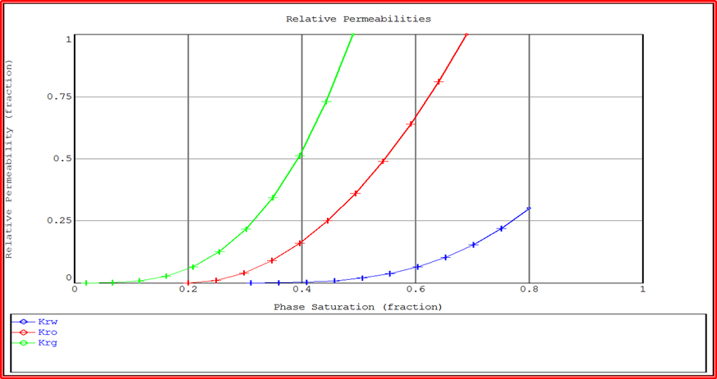 Figure(5.2) carve phase saturation(fraction) and relative permeability by MODEL: Carter-Tracy

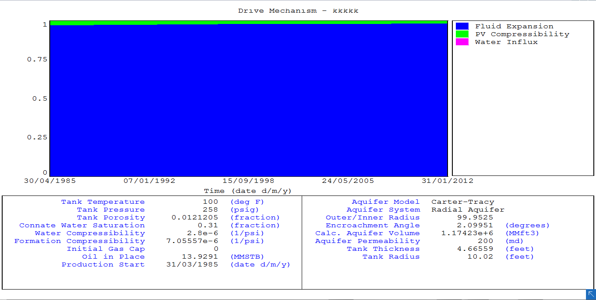
Figure ( 5.3) : Energy Plot
Fluid Expansion=75% PV comressibilitg=25%
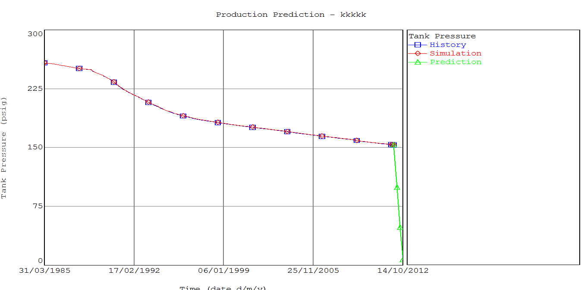
Figure ( 5.4 ) : Production Prediction

5.3 Discussion of Calculation :
In this report the production was started in (31/03/1985) The pressure in this year (258psi) was cumulative for oil, gas and water (mmstb 0.004774 oil, 0 mmscf gas, water mmstb 0 |) The cumulative production continued until the end of the year (31/01/2012)and was Pressure (153.435psi) and cumulative production (oil 1.11647 mmstb ,gas 0.263187 mmscf, water 0.134622 mmstb) Then we made a historical match by using a (small pot) in Run simulation . and Then we did a prediction to the year (14/12/2012) occurs drop in pressure to zero .

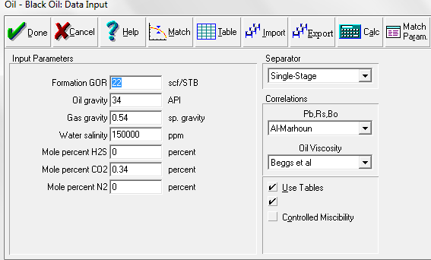
Figure 5.5: Oil-Black Data Input
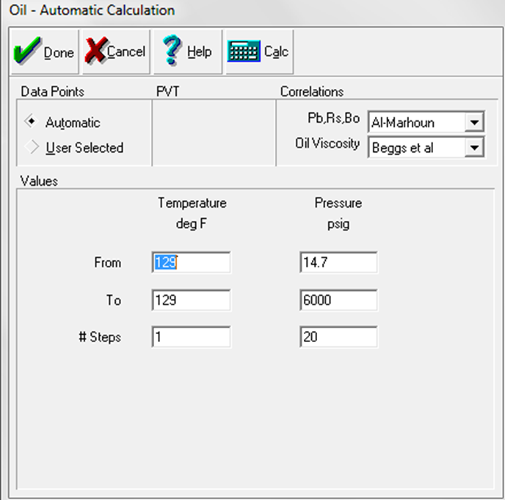
Figure 5.6: Oil-Automatic calculation
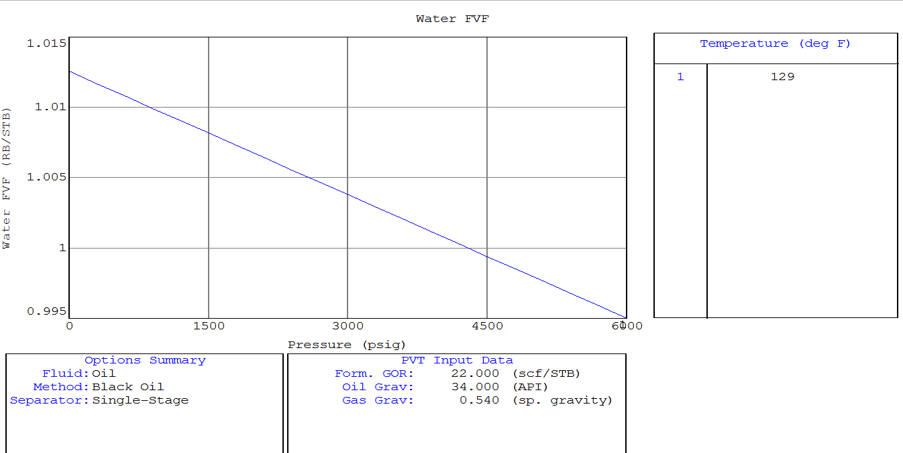
Figure (5.7) : water FVF with pressure

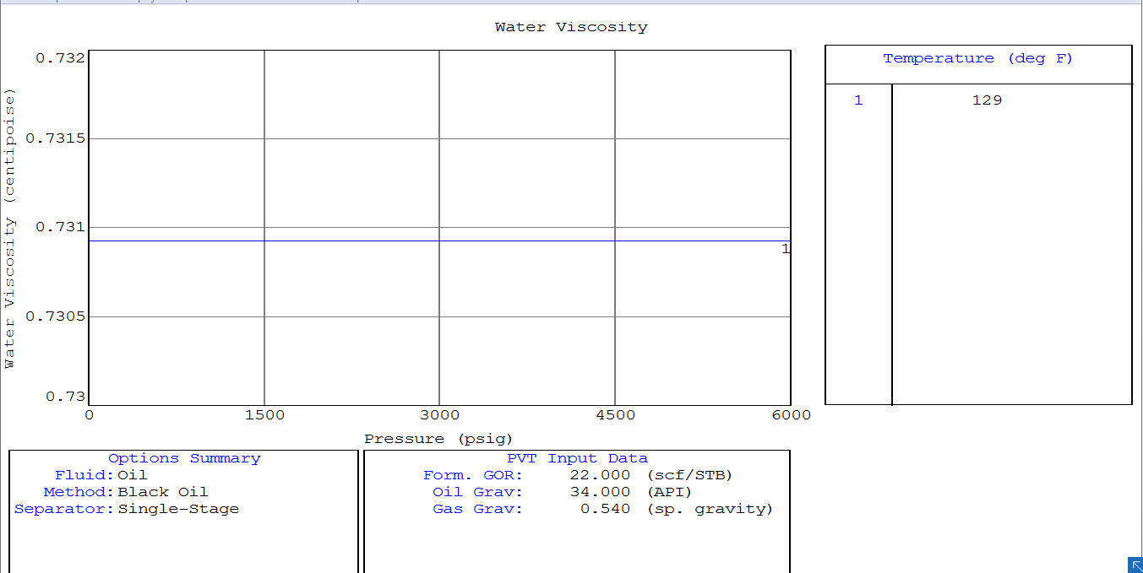
Figure (5.8) : water viscosity with pressure
Note Water viscosity it is constant so not change with the pressure at any time.

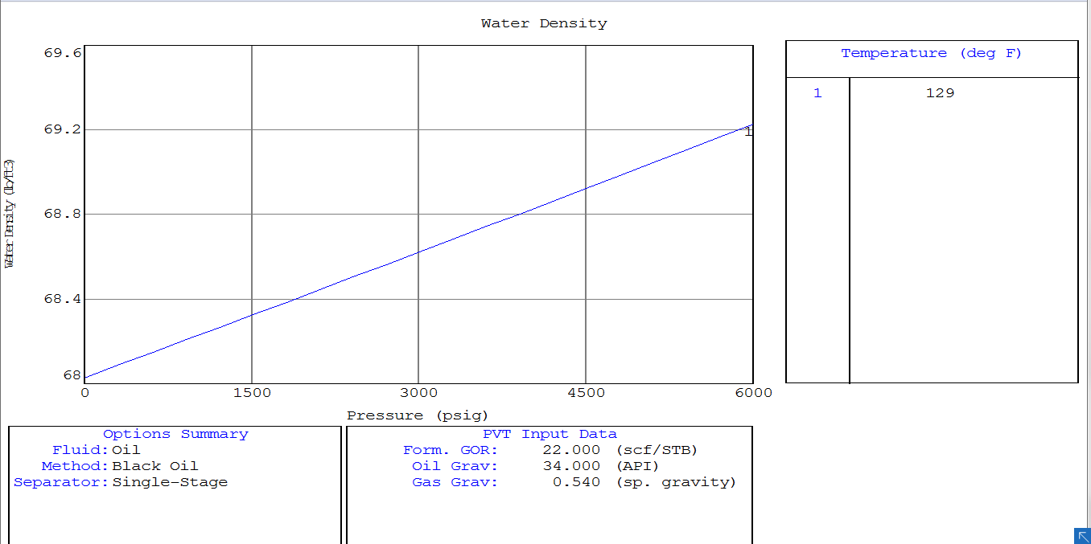
Figure (5.9) : water density with pressure

The water density it is change with ratio of salinity so The higher the salinity, the greater the density.

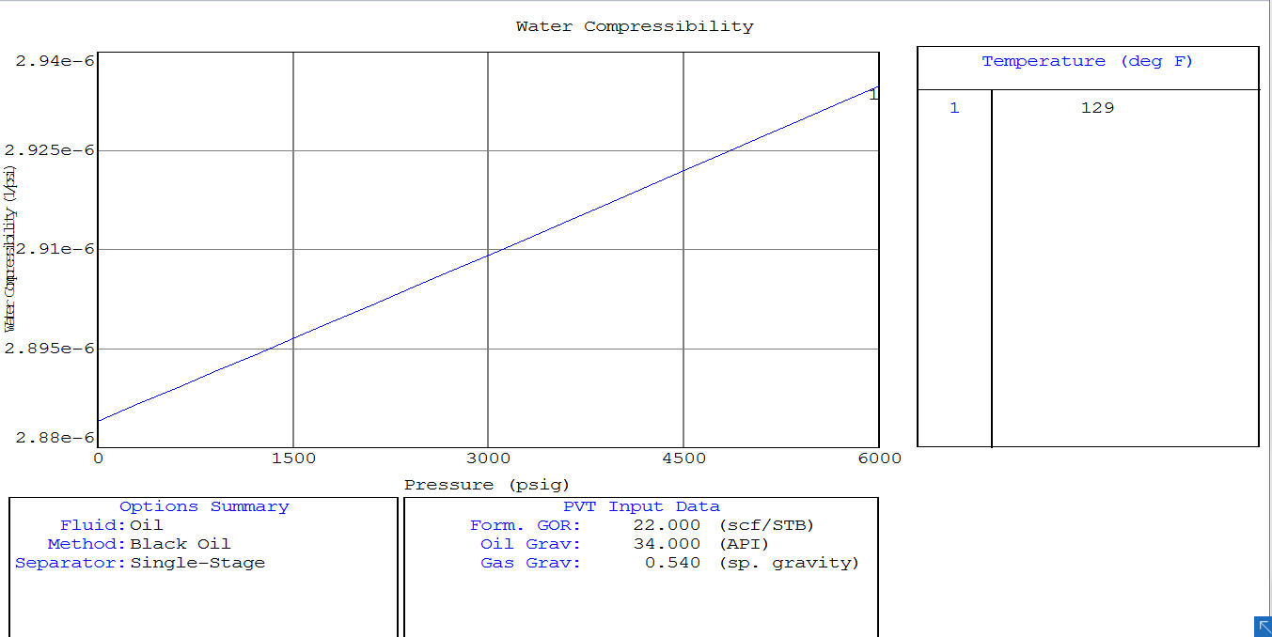
Figure (5.10) : water compressibility with pressure
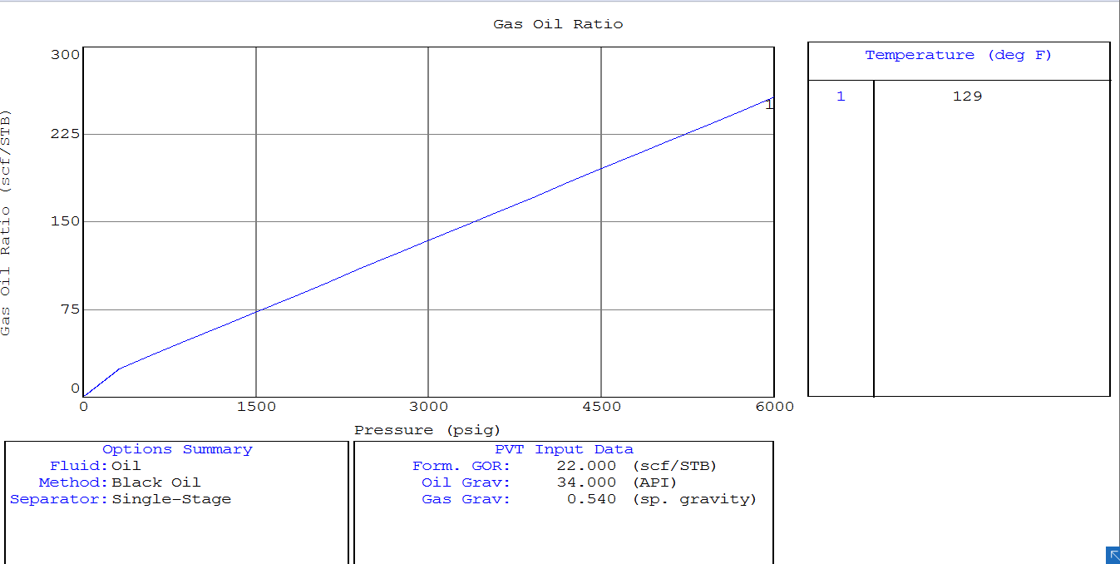
Figure (5.11) : gas oil ratio with pressure
Not When the pressure decreasing the gas while be free from the oil.

so we note that the ratio of gas to oil is constant in high pressure until it reaches the point of the bubble where the gases are released in the oil, which affects the linear relationship of the curve.

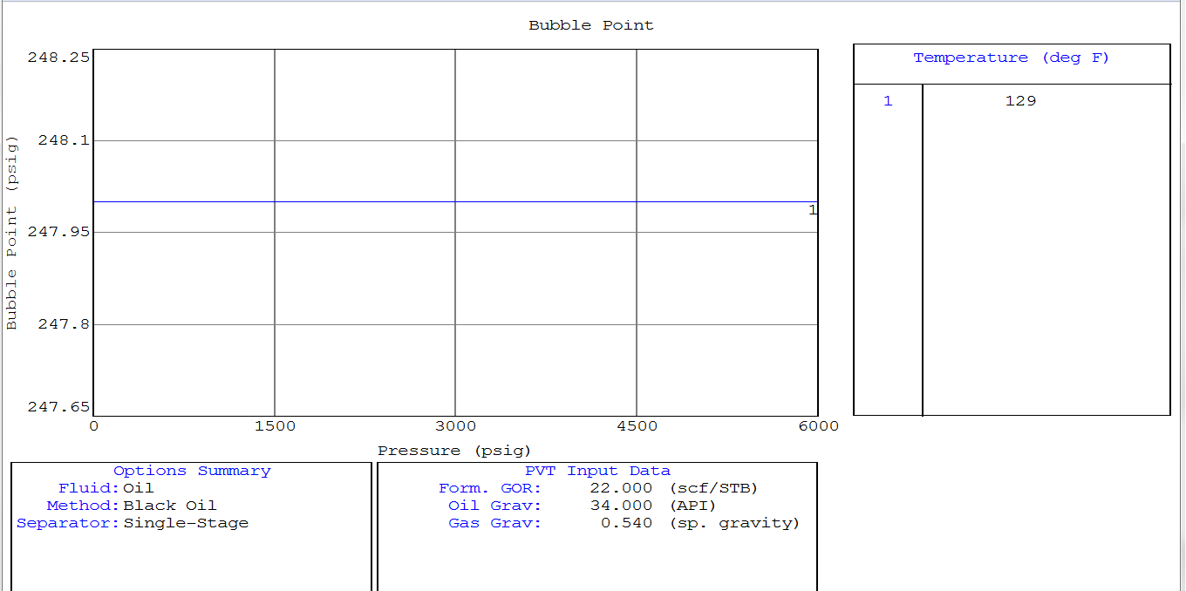
Figure (5.12) : bubble point with pressure

The pressure of the reservoir it is greet then the bubble point pressure so thr curve not change

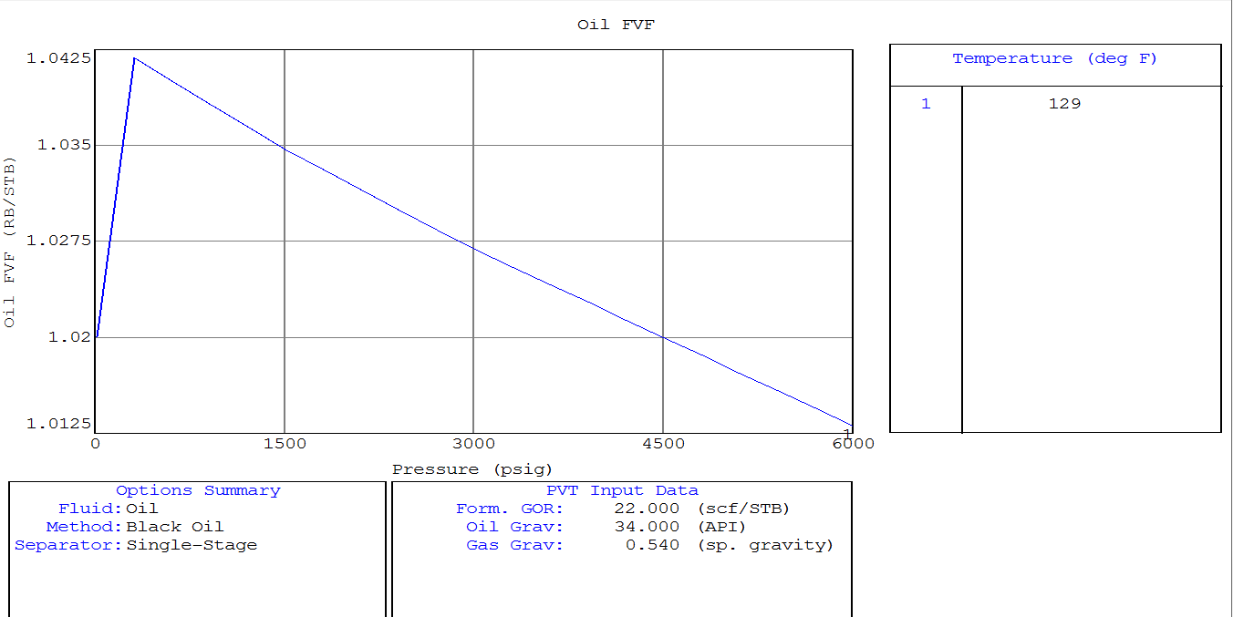
Figure (5.13) : Oil FVF With Pressure

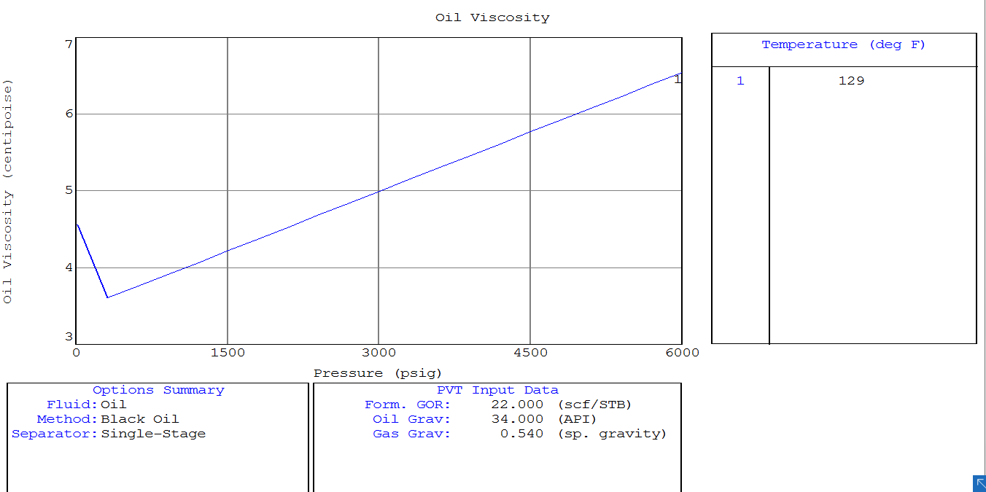
Figure (5.14) : oil viscosity with pressure

oil viscosity with pressure This curve represents the relationship between the viscosity and the pressure of gases. Here, with the increase in the rate of pressure of the reservoir increase the rate of viscosity, but also note that at the beginning of the curve gases are in their normal state and turned the gas situation, but with the high pressure the gas turns to liquefied gas and above the point of the bubble if The gas is more accurate to the viscosity after converting it into liquid state and we call it liquefied gas and the pressure continues to convert gas to liquid until the viscosity coefficient is constant
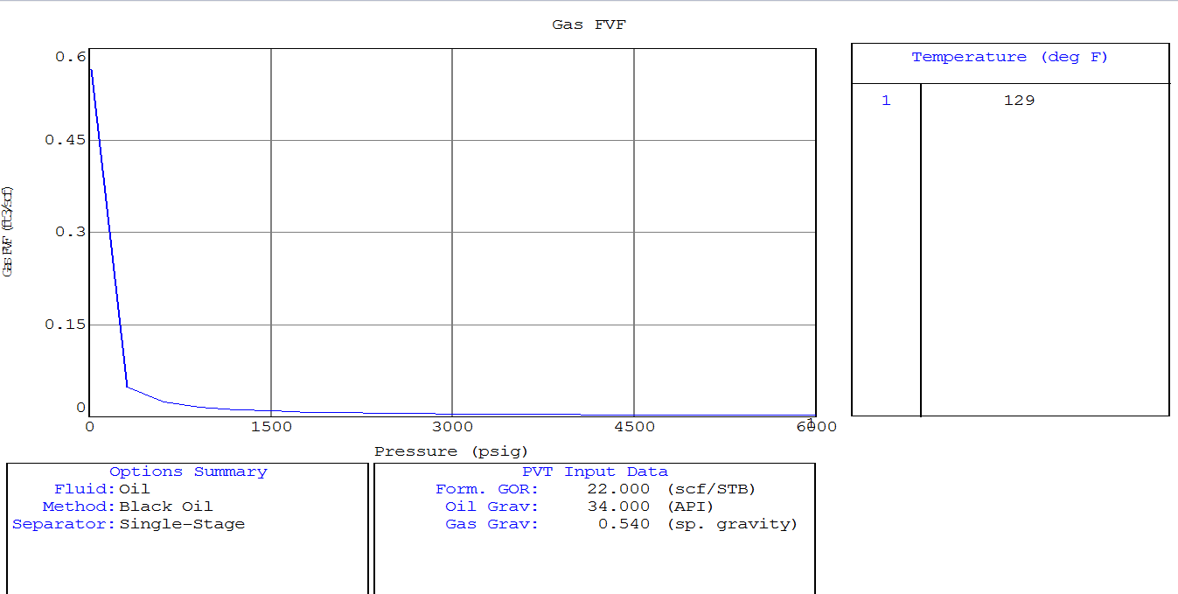
Figure (5.15) : gas FVF with pressure

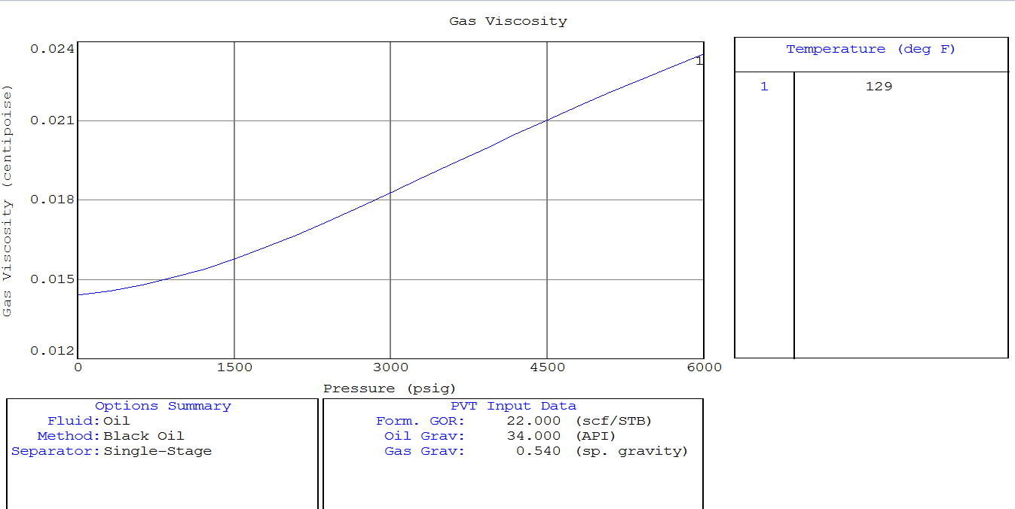
Figure (5.16) : gas viscosity with pressure

CHAPTER 8
Recommendations & conclusion

CHAPTER 6
Recommendations & conclusion

6.1 Conclusion

We conclude that these software petroleum experts(MBAL) The reservoir engineer can interpret and predict the well production and efficiency of the reservoir, and know the measures used to improve the increase rate of production.

6.2 Recommendations
In the case of drop pressure and low production efficiency, it is recommended that:
- - The use of water injection mechanism in the production zone .
- - The use of gas injection in the zone gas cap.
3. Use Enhanced oil recovery (EOR) methods.

References
- Master Of Science Of King Fahd University Of Petroleum And Mineral Thesis, Pp 109-114.M. A. Al-Marhoun, “Evaluation Of Empirically Derived PVT Engineering, Vol. 42, Pp. 209–221, 2004.
- Ahmed, T. “Reservoir Engineering Handbook” Fourth Edition, Gulf Professional Publishing Is An Imprint Of Elsevier, 2010.
- Properties For Middle East Crude Oils”, Journal Of Petroleum Scienceand
- M. B. Standing, “A Pressure–Volume–Temperature Correlation For Mixtures Of California Oils And Gases”, Drilling And Production. Am. Pet. Inst., Tulsa, OK, Pp. 275–287, 1947.
- Vogel, J. (Januray 1968). Inflow Performance Relationship For Solution Gas Drive Wells. London: J.Petroeun Technol.

