ENHANCING THE COLLABORATIVE WRITING THROUGH USING GOOGLE DOCS TO EFL UNIVERSITY STUDENTS IN SEBHA CITY, LIBYA

By
MALAK ALI SASI

A final project submitted in partial fulfillment of the requirements for the degree of bachelor in English language with a focus on applied linguistics

SEBHA UNIVERSITY
Department of English

January 2019
© Copyright by MALAK ALI SASI, 2019
All Rights Reserved

To the Faculty of Sebha University:
The members of the Committee appointed to examine the B.A. final project of Malak Ali Sasi find it satisfactory and recommend that it be accepted.

The advisor’s name
T. Zamzam Amhimmid Mare

The examiner’s name
………………………………….

ACKNOWLEDGMENT
I thank Almighty Allah, without whose origin of wisdom, knowledge and sustenance my human pursuits would be in vain.
I would like to express my sincere gratitude and appreciation to the many people who contributed to the successful completion of this thesis. My fondest gratitude goes to:
- I am very much thankful to my supervisor, T. Zamzam Amhimmid Marefor her deep academic insight, guidance and gracious support which sustained me throughout the writing of this thesis.
- My parents {Faddolah&Ali {thank you for your cheerful disposition. Your support and encouragement generated the energy which drove me to complete this study.
- My sister,} Marwa{ and my brothers } Mohammed , Hassan and Abdulrahman{ , whose love kept me going through difficult times.
- The entire family: I feel blessed to be part of you, because of your love and support throughout all activities in my life.
- Many friends and colleagues, classmates and other graduate students who made my journey worthwhile. To} Rima Ali Yahya&Marwa Mohammed Salah { , thank you for the comforting words, for always being there for me and for listening to my frustrations throughout this process and encouraging me to reach the finishing line.
- The teachers who participated in this study, I thank you, because without your willingness and cooperation, this work would not exist.
May this thesis be a source of inspiration and encouragement to you all.
ENHANCING THE COLLABORATIVE WRITING THROUGH USING GOOGLE DOCS TO EFL UNIVERSITY STUDENTS IN SEBHA CITY, LIBYA

Abstract
By
MALAK ALI SASI
Sebha University
2019

Google Docs, an online word processing application, is a promising tool for collaborative learning. This paper will discuss the advantages of using Google Docs as an effective teaching aid for enhancing collaborative writing. An observation and a test was undertaken to provide insight into the merits and challenges of its use. The participants were 40 students from first semester who study in the English Department in Sebha University. The results suggest that Google Docs is a useful tool for collaborative writing and influences student learning.

TABLE OF CONTENTS
Chapter Numbers | Title and subtitles of the chapters | Page number
 | Acknowledgements | .iii
 | Abstract | iv
 | List of tables | X
 | Abbreviations | XI
Chapter 1 | Introduction
1.1. | Overview | 1
1.2. | Research problem | 1
1.3. | Question of the research | 2
1.4. | Significant of the research | 2
1.5. | Assumption of research | 2
1.6. | Organization of research | 2
Chapter 2 | Literature review
2.1. | Introduction | 3
2.2 | Academic Writing; definition and importance | 3
2.3. | The strategies of teaching Academic writing for University students | 4
2.3.1 | Modeled writing strategy | 5
2.3.2 | Think aloud writing strategy | 5
2.3.3 | Guided writing strategy | 6
2.3.4 | Independent writing | 6
2.4. | Google Docs; Definition and nature | 6
2.4.1 | Benefits of Using Google Docs in ELT | 7
2.4.2 | Using Google Docs for teaching writing collaboratively | 8
Chapter 3 | Methodology
3.1. | Introduction | 11
3.2. | Methods | 11
3.3. | Participants and settings | 11
3.4. | Instruments | 11
3.5. | Procedure | 12
Chapter 4 | Analysis, findings and discussion
4.1. | Overview | 14
4.2. | Classroom observation | 14
4.2.1. | Analysis of classroom observation | 14
4.2.2. | Findings of Classroom observation | 14
4.2.2.1 | The ways of teaching writing for the first semester in the English department of Sebha | 14
4.2.2.2. | The students' level, participation and collaboration in the classes of writing | 15
4.3. | A test | 15
4.3.1. | Analysis of a test | 15
4.3.1.1 | Pre-test analysis | 16
4.3.1.2. | Post-test analysis | 18
4.3.2 | Findings of the test | 19
4.4. | Discussion | 19
Chapter 5 | Conclusion
5.1. | Introduction | 22
5.2. | Conclusion | 22
5.3. | Recommendations | 22
5.4. | Further study | 23
 | References | 24
 | Appendix 1 | 28

LIST OF TABLES
Table 1: | The students' grades of pre-test | 16
Table 2: | The students' mistakes in pre-test | 17– 18
Table 3: | The students' grades of post-test | 18– 19
Table 4: | The students' mistakes in post-test | 19- 20

List of abbreviation
Google Docs | Google Documents
EFL | English as a foreign language
ELT | English language teaching
L2 | Second Language
NSW | New South Wales

CHAPTER ONE:
INTRODUCTION
  - Overview
Use of technology in (EFL) classroom is becoming an increasingly familiar phenomenon. The recent study measures the usefulness of using a technology like Google Docs in an out of the class as a collaborative activity for introductory writing courses. The aim of this research is to teach students to work collaboratively and to positively communicate with understanding while writing. Among newly developed online applications, Google Docs is an especially promising tool for collaboration (Gralla, 2010; Morales & Collins, 2007). According to Limbu and Markauskaite (2015), collaborative writing tools such as Google Docs enable learners to participate, and to form communities that engage in purposeful communication.
1.2. Research Problem
Most of the students in English department face various difficulties in learning writing skill such as mistake in organization of ideas, using punctuation, capitalization problems, wrong grammar and spelling. However, the students in first semesters sometimes do not know how to write in an academic way, cannot develop their idea and refuse to work together as a result they get bored while the writing process.
Additionally, most of the English language teachers ignore using technology while teaching writing in their classes. The problems also come from those lecturers or teachers in using the uninteresting technique or the conventional technique to teaching writing. These problems will cause the less of interest and demotivate students while writing. Thus, this study is an attempt to use Google Docs as a tool to enhance academic writing skill for students.
1.3. Research Question-s
This study focuses on using Google Docs as a motivational tool for (L1st semester) to enhance the collaborative writing to EFL university students in Sebha City, Libya. It will mainly highlight the answers to the following questions:
- What are the advantages of using Google Docs for collaborative writing for first semester students in the English department of Sebha?
- What are the attitudes towards using Google Docs by first semester students in the English department of Sebha?
1.4. Significance of the study
It is hoped that this study will be of benefits to the members of the faculty of English language at the University of Sebha and for students of EFL who study writing as well. It will benefit teachers because it will add a variety to their lessons and the feature of giving direct feedback will help to ease the assessment process. Google Docs will help students as well because it will help to engage them in the process of collaborative writing in an interesting and advanced way.
1.5. Hypothesis of the study
It is hypotheses that collaborative writing and using Google Docs have directly positive and predictable effects on improving EFL students' writing skill.
1.6. Organization of the Study
This research has been organized into five chapters. The first chapter is introduction of the research. The second chapter is literature review. The third chapter is allocated to methodology that is used in this study. The fourth chapter is analysis, finding and discussion. The fifth chapter is conclusion and recommendations of the research.

CHAPTER TWO:
REVIEW OF LITERATURE
2.1. Overview
Many researches and studies have been conducted about using Google Docs to enhance Academic Writing.This section encompasses relevant information and findings from previous studies related to the topic.
2.2. Academic Writing: Definition and Importance
Academic writing differs from other types of writing such as journalistic or creative writing. It is the most important component of learning English. This importance is due to the fact that writing supports and reinforces grammatical structure, vocabularies, and arranging of ideas. Therefore, academic writing should receive more attention in EFL in order to make learners acquainted with the communicative demands of real life situation.
Tarnopolsky and Kozhushko (2007) explained academic writing as “the most creative type of writing that can be taught to students of English as a foreign or second language”, and have also account for it as “a unique means for learners’ consciously mastering the creative, productive, and expressive approach towards communicative performance in the target language” . Thus, Academic writing is highly required for university courses (Whitaker, 2009).
Bowker (2007) defined academic writing as “a special genre of writing that prescribes its own set of rules and practices” (p. 3). Hinkel (2004) stated that L2 writers require knowing more about the rhetorical and discoursing features of written English. In fact teaching academic writing cannot be achieved without grammar and vocabulary as they are necessary tools for writing academically. These rules and structures may be organized around a formal order where ideas presented to ensure that they are reinforced by authors' citations in the literature.Additionally, academic writing is strongly related with traditional conventions of punctuation, grammar, and spelling.
Irvin (2010) considered academic writing as “a form of evaluation that asks you to demonstrate knowledge and show proficiency with certain disciplinary skills of thinking, interpreting, and presenting” (p. 8).
2.3. The Strategies of Teaching Academic Writing for University Students
Kirby and Crovitz (2013) stated that “Teaching Academic writingis challenging; it may be one of the toughest jobs a teacher faces” (p. 9), however “it can also be rewarding” (p.11). The effective teaching of writing for Kirby and Crovitzr equires time divided between practice, sharing writing, completing the piece of writing, and time to respond and evaluate all of that writing (p. 9). The teaching of writing for advanced EFL students occurs with the help of certain strategies that aim at enhancing students’ writing productions. Teaching these strategies to learners will surely have a positive effect on their writing. For instances, teaching adolescents strategies such as planning, revising and editing their compositions has made a remarkable impact on the quality of their writing (Graham &Perin, 2007).
The writing strategies are various as their application and implementation in syllabuses. Thus, the teacher is the center point which directs the students towards a successful writing achievement. The writing strategies are identified by several researchers as the teaching of generic processes such as brainstorming (Troia & Graham, 2004), or the strategies for achieving writing tasks such as story writing (Fitzgerald & Markham, 1987).
Additional to the writing strategies writers may employ in during their composition, there exist a number of strategies used to engage students in writing. The NSW Department of Education and Training (2007) have proposed a series of strategies which promotes students to write and demonstrated their implementation in writing classes. These strategies will be discussed in the next section.
2.3.1. Modeled Writing Strategy
Teachers use this strategy to allow students “to gain knowledge about language, vocabulary and text structures required to write for a range of purposes” (The NSW Department of Education and Training, 2007, p. 29). Models used in this strategy are real world texts students read, they might vary from newspaper articles to literary works depending on the teacher’s selection. The implementation of this strategy starts by introducing the text type to students while clarifying the audience and the purpose behind writing the text. Then the teacher points out to the type and the features of language used by the author and its effect on the readers, and he ends up with providing students with chances to practice the writing skills they have acquired studying these models (p. 28).
2.3.2. Think Aloud Writing Strategy
Think aloud strategy is one way to engage students in writing that function as a stimulator for writing. Think aloud is defined by The NSW Department of Education and Training (2007) as a method in which students are saying aloud what they are thinking about during their composition which helps them organize and edit their writing. In addition, The NSW Department of Education and Training asserted “It is a strategy that can be used to demonstrate a comprehensive range of skills, knowledge and understandings about writing” (p. 33). Moreover, the implementation of this strategy comes as the teacher selects a particular skill to focus on, and then he chooses few writing samples and apply the think aloud strategy in order to illustrate the reasoning and editing during writing.
2.3.3. Guided Writing Strategy
In guided writing strategy, the teacher's role is as the name of the strategy denotes is a guide for students, and they work cooperatively in order to compose a written text. This strategy “can involve the whole class, small groups or individuals”, it can also be with help of the teacher “a key strategy for assisting students who need additional support in writing” (The NSW Department of Education and Training, 2007, p. 34). In short, guided writing emphasizes on the role of the teacher in fostering and facilitating student’s writing, by focusing on their needs, measuring and assessing the students’ achievement of the outcomes. Then the teacher helps students building prior knowledge and skills students develop in writing (The NSW Department of Education and Training, 2007).
2.3.4. Independent Writing
The aim of this strategy is to provide students with opportunities to explore their own skills in writing different text types (The NSW Department of Education and Training, 2007), apart from the teacher’s guidance and collaborative writing with peers. In independent writing, students learn to identify the purpose of their writing, the audience, and the use of different skills to help them accomplish the writing tasks. This strategy also helps students become aware of their writings increases self-assessment.
2.4. Google Docs; Definition and Nature
Google Docs is a free online word-processor that is available to anyone with Gmail account to create a collaboration activity. This tool provides standard editing functionality and really excels in real-time collaborative authoring. Google Docs is “a free, web-based word processor, spreadsheet, presentation, form, and data storage service offered by Google. It allows users to create, edit and store their document online” (Thompson, 2008).
Sharp (2009) suggested that this collaborative editing tools allow a group of individuals to edit a document simultaneously while they can view the changes made by others in real time. Since Google Docs is easy and fast, the tool is well-suited for facilitating digital writing workshops that combine peer editing with cooperative grouping and small group fine-tuned writing instruction. This special feature makes Google Docs a powerful program that can facilitate collaborative writing in the language classroom. By sharing documents and keeping them online, students can access them anytime.
Chinnery (2008) stated that Google Docs is a productive tool where learning activities can be designed differently and creatively. For instance, an instructor might post a text, intentionally replete with errors, for learners to correct. According to Oxnevad (2013), document sharing and comments are features in Google Docs and these features provide students with opportunities to receive immediate feedback
Among many technologies, Google Docs is a learning tool which helps to implement the learner-centered approach in a collaborative learning environment.
2.4.1. Benefits of Using Google Docs in ELT
Using Google Docs is a useful tool that makes online learning environment possible. It is the tool that supports students to help one another in learning without restriction of time and place. Students can gain knowledge by comparing two versions of a document hence, increasing understandings of how sentences should be corrected. Google Docs makes collaboration easier. It is accessible to the general public, regardless of location, as long as the Internet is available (Oishi, 2007).
For Google Docs, the students know that their teacher can check who works less or more throughout the learning process. As such, students in the Google Docs group are more serious about collaborating and willing to follow the group conventions and practices. This may affect the improvement of the two groups’ writing abilities (Elola&Oskoz, 2010). Online collaborative writing improved fluency and accuracy and valued the opportunity to share feedback with peers (Ware & O’Dowd, 2008). According to (Zhu, 2012) through online, collaborative written assignments, group discussions, debates and critiques of arguments, students can enhance knowledge construction.
The ability to share and edit documents between group members makes collaboration much easier (Chiu, Wang, Popescu, Li & Lau, 2014, p.150). Google Docs allows students to share a draft via email or Google Docs, where they can instantly edit and provide and this in turn saves them from completely rewriting their drafts (Curtis, 2013). Google Docs also expunges issues of geographical boundaries, making it easier to work from any location in the world. The comments in Google Docs also encourage students to reply to their teachers and peers’ comments, thus increasing their motivation (Al-Chibani, 2016). This sharing of experiences in an asymmetric manner until creation of the final product, works to keep the motivation levels of students’ high (Mitnik, Recabarren, Nussbaum, & Soto, 2009; Suwantarathip&Wichadee, 2014).
2.4.2 Using Google Docs for Teaching Writing Collaboratively
Google Docs can be a good, rich and helpful toolto teach writing as instructors can easily review the steps that students took in order to better assess the choices these writers made in drafting the paper.
Despite Google Docs’ potential, many college students and instructors lack knowledge of effective ways of using Google Docs to enhance teaching and learning. There has been reluctance in adopting online applications in higher education because online collaboration can lead to both positive and negative educational outcomes. Although a number of studies have found that the use of online technology in the classroom can facilitate collaborative learning among students and promote learning outcomes (Chou & Chen, 2008; Raman, Ryan, &Olfman, 2005; Vaughan, 2008), online collaborations might also lead to unpleasant learning experiences and outcomes in traditional face-to-face classrooms (Blau&Caspi, 2008). For example, students and instructors might feel uncomfortable in sharing knowledge (Rick &Guzdial, 2006), or students may not all contribute equally to the assignment.
Getting feedback and making improvements needs to be a continuous cycle for students and they need to see that they are improving with each draft. Oftentimes student writers do not realize how crucial revision and editing are to the writing process, that these tasks are just as important as completing a draft. Zheng, Lawrence, Warschauer, and Lin (2015) found that some students spent more time editing and revising their work when they used Google Docs than they previously had done with paper documents, which led the researchers to conclude that Google Docs provides encouragement for process-writing.
Teachers need a way to continue to motivate students to revise and to help them see the errors or problems in their writing and care about changing them and new technologies offer a way to do just that. Teachers can use a few technology tools to help with student motivation and interest. It is argued that most of the activities in the writing classroom can be performed through Google Docs: drafting, revising, and peer editing, collaborating, and providing feedback. Students can work through various drafts of their papers and instructors can check in and provide feedback at multiple points in the process. Students can easily highlight sections of their paper about which they have questions or concerns.

CHAPTER THREE:
METHODOLGY
3.1. Overview
In this chapter, the researcher will talk about the research methodology used in this research, the details of the participants who were chosen as a sample of the study, tools and techniques used for collecting the research related data and steps which are followed to collect and analyses the data.
3.2. Methods
The research instrument that the researcher has chosen for this study are qualitative method. This method are chosen because this study requires exploring the students’ motivation and development in writing classes. The researcher can get more information when using a qualitative research method such as test or observation. This will help to explore the benefits of using Google Docs to enhance the collaborative writing to EFL university students in Sebha City, Libya. The data were also collected from books, ELT journals, websites and published dissertations.
3.3. Participants and Settings
The participants of the observation consist of 40 students (36 female and 4 males). The participants of the test are 10 participants (6 females and 4 males). Their ages were between 18 to 21 years old. The number of females is more than the number of males due to the fact that there are only four males studying in the selected class. All the participants are from the first semester in the English department of Sebha/ Libya.

3.4. Instruments
The researcher used two tools to collect the data related to the present study. The first instrument is a classroom observation. This method is used to see how writing is being taught to first semester students in the English department. It aims also to observe the students’ level in the class and whether they collaborate together while writing. In addition, the researcher observed the students’ perceptions and progress while using Google Docs. Simpson and Tuson (1995) regard observation as "one of the most versatile ways of gathering information" (Simpson and Tuson, 1995, p. 3). Observation is a data collection method used to gather detailed information about a situation or event. Observation data is used to describe the setting, activities, participants, and the meaning of the observations from the observer's perspective (patton, 2002). Observation data should be factual and accurate. The second instrument was a test, in which the researcher makes a (pre-task and the post-task) to compare students' performance before and after the use Google Docs.
3.5. Procedure
First,I stated the aims of the current study and read the relevant information from different sources about the topic. Secondly, I chose the participants and took permission from the teacher of the subject to attend the writing classes. Then, the observation was started with 40 students from first semester to know their levels in writing classes. This process was done during one complete semester in which I attended all the lectures with the selected class. After that, a test wasmade with 10 students before the use of Google docs. 10 students weretrained by the researcher to use Google Docs. Students were taught to use Google Docs in and outside the class. Meanwhile, students were given one week to create Gmail accounts (if they did not already have one), and were asked to share their Gmail e-mail address with the researcher and the teacher. Ablank Google doc was created for each group, and was shared each Google Doc with its respective group members. The process of training students and writing on Google Docs took about three weeks.
Another test was done with the same selected participants after the use of Google Docs to measure the students' progress through collaborative work by using Google Docs. The two tests and the training process took about two months. After collection of data, the data were classified, analyzed and evaluated to draw the conclusion regarding the aims of the study. This study employed qualitative approach of data analysis.

CHAPTER FOUR:
ANALYSIS, FINDINGS AND DISCUSSIONS
4.1. Overview
In this chapter,firstly, the researcher will analyze the data, then will report the findings of the data analysis, and finally, will discuss the findings of the data analysis by related them with the aims of the study and the research questions.
4.2. Classroom Observation
The observation is the first used instrument in this study. Below, there are more details about the analysis and findings of the observation.
4.2.1. Analysis of Classroom Observation
The aim of the observation is to know the ways of teaching writing for the first semester in the English department of Sebha. Furthermore, this observation intends to have a closer idea on the students' level, collaboration and participation in the classes of writing. The information was noted down in the form of notes and analyzed. The next section will be about the findings of the observation.
4.2.2. Findings of Classroom Observation
4.2.2.1. The Ways of Teaching Writing for the First Semester in the English Department of Sebha University
From the observation, it is noticed that there are many ways and strategies used for teaching Academic Writing for the first semester students. The teacher uses a book for teaching writing "Introduction for Academic Writing". This book contains a wide range of writing exercises and tasks that are targeted for beginners. The teacher explains the writing lesson from the book; she uses the whiteboard and then helps students to practice these lessons through solving the attached exercise and tasks. The teacher does not depends only on the book as she designs some tasks, games and quizzes, sometimes at the beginning of a class or at the end of the lesson. In terms of using technology, the teacher gives small introduction about using Google Docs but the students do not practice it seriously during the semester because of the lack of internet and electricity during the writing lessons.
4.2.2.2. The Students' Level, Participation and Collaboration in the Classes of Writing.
In terms of the students' level, it is observed that the students' levels were varied. The majority of the students had a low level in terms of writing in the first classes. Few of the students were good in writing. The students' level of most of the students is increased gradually in later classes.
In terms of participation, it is noticed that the students' individual participation was high as the exercises were interesting and encouraging.
In terms of collaboration, it is observed that their collaboration was low during the whole semester, as most students did not cooperate together actively when they are asked to work in groups. This indicates that most of the students do not know the benefits of collaborative working to improve their writing skill.
4.3. The Test
The test is the second used instrument in the current study. Below, there are more details about the analysis and findings of the test
4.3.1. Analysis of The Test
As mentioned earlier, the researcher made two tests; a pre-test (before using Google Docs) and a post-test (after using Google Docs). For the first test, each student wrote individually a letter on a paper. The researcher gave a task to 10 students and asked them to write a letter to a friend. After that, students were asked to work collaboratively in two groups and each five students wrote a letter on Google Docs. The second test was done after using Google Docs. For the second test, the same students wrote individually a about their morning routine. Those written works were marked by both the teacher and the researcher. The written works were corrected upon the following criteria; margins, spelling, grammar, organization and punctuation. The total mark out of 10. However, 2 marks were given for each of the previous mentioned criterion. Below are the details of the results of both tests.
4.3.1.1. Pre-test Analysis
Here are the results of the pre-test according to the final grade
Students | Margin | Spelling | Grammar | Organization | Punctuation | Total Grade
Students 1 | 1.5 | 1.5 | 1.5 | 1.5 | 1.5 | 7.5
Students 2 | 2 | 1.5 | 1 | 1.5 | 2 | 8
Students 3 | 1.5 | 0.5 | 1 | 1 | 0 | 4
Students 4 | 2 | 0.5 | 1.5 | 1.5 | 2 | 7.5
Students 5 | 2 | 1.5 | 1.5 | 1.5 | 2 | 8.5
Students 6 | 2 | 1 | 1 | 1 | 0 | 5
Students 7 | 1.5 | 0.5 | 2 | 1.5 | 2 | 7.5
Students 8 | 2 | 0.5 | 2 | 1.5 | 0.5 | 6
Students 9 | 2 | 0.5 | 0.5 | 0.5 | 1 | 4.5
Students 10 | 1 | 0.5 | 1 | 1 | 1 | 4.5
Table 1: the students' grades of pre-test
Table (2) shows the number of mistakes according to margins, spelling, grammar, organization and punctuation. The symbol () indicates that there is no mistakes in the given criterion.
Student | Margins | Spelling | Grammar | Organization | Punctuation | Total Number of Mistakes
Students 1 | 2 | 2 | 2 | 2 | 2 | 10
Students 2 |  | 2 | 3 | 2 |  | 7
Students 3 | 2 | 4 | 3 | 3 | 10 | 22
Students 4 |  | 4 | 1 | 2 | 1 | 8
Students 5 |  | 1 | 2 | 2 |  | 4
Students 6 | 2 | 18 | 1 | 3 | 14 | 38
Students 7 | 1 | 4 |  | 1 | 1 | 7
Students 8 | 1 | 6 | 4 | 2 | 7 | 20
Students 9 |  | 4 | 4 | 5 | 2 | 15
Students 10 | 2 | 4 | 2 | 2 | 2 | 12
Table 2: the students' mistakes in pre-test
4.3.1.2. Post-Test Analysis
After the pre-test, the researcher trained the students to use Google Docs and collaborate together by dividing them in two groups. Screenshots were taken to track their progress and work until they reach the final result. Appendix 1 contains the works of the two groups by using Google Docs
After using Google Docs, the researcher gives the participants another test and they work it individually (write about your morning routine). Here are the results of the post-test according to the final grade
Students | Margin | Spelling | Grammar | Organization | Punctuation | Total Grade
Students 1 | 2 | 2 | 1.5 | 2 | 1.5 | 9
Students 2 | 2 | 1.5 | 1.5 | 2 | 2 | 9
Students 3 | 2 | 1 | 2 | 2 | 1 | 8
Students 4 | 2 | 1 | 1.5 | 2 | 2 | 8.5
Students 5 | 2 | 1.5 | 1.5 | 2 | 2 | 9
Students 6 | 2 | 1 | 1.5 | 1.5 | 1 | 7
Students 7 | 2 | 1 | 2 | 2 | 2 | 9
Students 8 | 2 | 1 | 2 | 2 | 1 | 8
Students 9 | 2 | 1 | 1 | 2 | 1.5 | 7.5
Students 10 | 1.5 | 1 | 1 | 1.5 | 2 | 7
Table 3: the students' grades of post-test
Table (4) shows the number of mistakes according to margins, spelling, grammar, organization and punctuation.
Student | Margins | Spelling | Grammar | Organization | Punctuation | Total number of mistakes
Students 1 |  |  | 1 |  | 1 | 2
Students 2 |  | 2 | 2 |  |  | 4
Students 3 |  | 4 |  |  | 1 | 6
Students 4 |  | 3 | 1 |  |  | 4
Students 5 |  | 1 | 1 |  |  | 2
Students 6 |  | 2 | 1 | 2 | 4 | 9
Students 7 |  | 3 |  |  |  | 3
Students 8 |  | 4 |  |  | 4 | 8
Students 9 |  | 3 | 3 |  | 1 | 7
Students 10 | 1 | 3 | 1 | 1 |  | 6
Table 4: the students' mistakes in post-test
4.3.2. Findings of the Test
The two tests that are used for students in the English department at Sebha University are used to investigate if there is any difference between the individual work and collaborative work on writing, and if the Google Docs is more helpful when students use it. The test results indicate clearly that the students' collaborative work through Google Docs improved the students' writing level. The participants in the Google Docs groups were more serious about collaborating and agreed to follow the group rules and practices. As a result, the selected participants' motivation and levelswere increased when they used this technology in terms of margins, spelling, grammar, punctuations and the overall organization of the paper.
4.4. Discussion
The current study aims mainly to answer two research questions. The first question is"What are the advantages of using Google Docs for collaborative writing for first semester students in the English department of Sebha?". The results of the study show that using Google Docs has many advantages and benefits for the EFL students. One of the main benefits found by the researcher was the collaborative function of Google docs and how instructor and students can provide comments, constructive criticism and ask questions on each other's work.
Another benefit raised by researcher was the ability to add additional notes, resources and relevant web links after the class. Illich (1971) confirmed this as he consented that the user of Google Docs can add links which will help to provide the students with additional information, and also stimulate learner autonomy and motivation.
However, other studies have found that students' involvement in learning activities via collaborative tools improves their final course grades (Ravid, Kalman, &Rafaeli, 2008).Students in the previous study also tended to agree that the use of Google Docs helped the students with the retention of key points despite taking less notes. In higher education, educators have begun to explore the educational merits of Google Docs. One study reported that students found Google Docs more enjoyable to use when compared to Microsoft Word (Apple et al., 2011). Additionally, when editing papers and writing a concluding paragraph, students wrote longer essays and were able to work on collaborative writing more efficiently, finishing more quickly when using Google Docs as compared to Microsoft Word (Apple et al., 2011).
The second research question was "What are the attitudes towards using Google docs by first semester students in the English department of Sebha?".In the first classes, the students were afraid and did not show cooperation with both the teacher and the researcher. The researcher then selected a small number of students and after a small introduction of this program; they were surprised that it was an easy program. The students then started to collaborate together and they were able to understand most of the options in Google Docs by themselves. The students showed a positive attitude towards the use of Google Docs.This technology changed their means of communication during collaborative writing.The finding of a similar study by Zhou et al (2012) revealed that all the students indicated that they were willing to use Google Docs in the future.Students also valued Google Docs as an “easy means of communication,” since it is “accessible,” and “makes sharing and editing among peers easier.”Suwantarathip and Wichadee (2014) also in their study observed that students who used Google Docs were confident in sharing their ideas with others. Additionally, Kessler et al. (2012) noted through a survey that students felt that each member of the group had contributed and had a valuable role when working online.
To conclude, the findings of the study and various studies indicate that the use of technology has the greatest positive impact when the learning aims are clearly established from the outset.Teachers therefore need to provide training to some students for accessing Google Docs so that they can take full advantage of the technology.

CHAPTER FINE:
CONCLUSION AND RECOMMENDATIONS
5.1. Overview
In this chapter, the researcher will talk about conclusion,recommendation, future study and limitations.
5.2. Conclusion
This research explores the benefits of using Google Docs as way of encouraging collaborative work which will then lead to enhance EFL students' writing skill. Google Docs is a popular collaborative writing tool which is part of a free, web-based software office suite offered by Google within its Google Drive service. Contribution to do the writing tasks which can be seen by the students and teacher is one factor to put more effort in their work. The ability to share and edit documents between group members makes collaboration much easier (Chiu, Wang, Popescu, Li & Lau, 2014, p.150). Despite Google Docs’ potential, many college students and instructors lack knowledge of effective ways of using Google Docs to enhance teaching and learning. Therefore, the present study has some recommendations that would be of great value of both EFL teachers and students.
5.3. Recommendations
- Teachers in the English department of Sebha must be encouraged to be open to new technologies and be creative in the use of technology to facilitate student learning.
- Teachers should be trained on how to use new technologies because integrating technology will impact the cognitive, social, and cultural dimensions of teaching.
- Students also must be trained as well to be able to use new technology like Google Docs in their learning process.
5.4. Further Study
It is hoped that other researches will be done with different levels to examine the effectiveness of using Google Docs to enhance Writing projects and collaborative writing.
5.5. Limitations
The research has its limitations and they need to be acknowledged. The first limitation is the number of samplings. This study was limited to only 40 learners of the observation and only 10 students in the test due to time-constraint to this study and due to the lack of reliable internet connection for students. Large number of participantswould have given more insights into the topic investigated. Therefore, a more detailed study, involving large number of participants is required for gaining better understanding on the topic.

REFERENCES
Apple, K. J., Reis-Bergan, M., Adams, A. H., & Saunders, G. (2011).Online tools to promote student collaboration. In D. S. Dunn, J. H. Wilson, J. Freeman, & J. R. Stowell (Eds.), Gettingconnected: Best practices for technology enhancedteaching and learning in high education (pp. 239-252). New York, NY: Oxford University Press.
Al-Chebani, W. (2016).Impact on Student Motivation of Integrating Google Docs within a Remedial English Writing Class. ICICTE 2016 Proceedings, 333-340.
Blau, I., &Caspi, A. (2008). Don’t edit, discuss! The influence of Wiki editing on learning experience and achievement.In D. Ben-Zvi (Ed.), Innovative e-learning in higher education (pp. 19-23). Haifa, Israel: University of Haifa.
Bowker, N. (2007). Academic Writing: A Guide to Tertiary Level Writing, Students Learning Development Services: Massey University, Student life Palmerston North.
Chinnery, G. (2008). ON THE NET You’ve Got some GALL: Google-Assisted Language Learning. Language Learning and Technology,12(1), 3-11.
Chinnery, G. (2015).”On The Net You’VEGot some GALL: Google- Assisted Language Learning. Language Learning and Technology”. 12(1), 3-11.
Chiu, D.K.W., Wang, M., Popescu, E., Li, Q., Lau, R. (2014). New Horizons in Web Based Learning. ICWL 2011 International Workshops, KMEL, ELSM, and SPeL, Hong Kong, 1-364.
Chou, P. N., & Chen, H. H. (2008). Engagement in online collaborative learning: A case study using a web 2.0 tool. Journal of Online Learning and Teaching, 4(4), 574-582.
Curtis, A.K. (2013). Writing 2.0: Google Docs as a Collaborative Writing Tool in the Elementary Classroom. Utah Valley University Library
Elola, I., &Oskoz, A. (2010). Collaborative writing: Fostering foreign language and writing conventions development. Language Learning & Technology, 14(3), 51–71. Retrieved from http://llt.msu.edu/issues/october2018/elolaoskoz.pdf
Fitzgerald, J. & Markham, L. (1987).Teaching children about revision in writing. Springfield, VA.: ERIC Document Reproduction Service.
Graham, S., &Perin, D. (2007).Writing next. Washington, D.C.: Alliance for Excellent Education.
Hinkel, E. (2004).Teaching Academic ESL Writing: Practical Techniques in Vocabulary and Grammar: Seathle University.
Illich, I. (1971). Deschooling Society. NY: Harper & Row.
Irvin, L. L. (2010). What is “Academic” Writing?. Retrieved from http://wac.colostate.edu/books/writingspaces1/irvin--what-is-academic-writing.pdf
Kessler, G., Bikowski, D., & Boggs, J. (2012).Collaborative writing among second language learners in academ-ic web-based projects. Language Learning & Technology, 16, 91-109.
Kirby, D. L., &, Crovitz, D. (2013). Inside out. Portsmouth, NH: Heinmann.
Macdonal, J. “Blended Learning and online tutoring: A good practice guide”. Aldershot, UK: Gower. 2006.Oxnevad, S.”6 Powerful Google Docs Features To Support The Collaborative Writing Process”.2013. web. 2 September 2015.
NSW Department of Education and Training (2007). Writing and spelling strategies. Darlinghurst: NSW.
Oishi, L. (2007). Working together: Google Apps goes to school. Technology & Learning, 27(9), 46-47.
Raman, M., Ryan, T., &Olfman, L. (2005).Designing knowledge management systems for teaching and learning with wiki technology. Journal of Information Systems Education, 16(3), 311-320.
Ravid, G., Kalman, Y.M., &Rafaeli, S. (2008). Wiki books in higher education: Empowerment through online distributed collaboration. Computers in Human Behavior, 24(5).
Rick, J., &Guzdial, M. (2006).Situating CoWeb: A scholarship of application. International Journal of Computer-Supported Collaborative Learning, 1(1), 89-115. doi:10.1007/s11412-006-6842-6
Sharp, V. (2009). Computer education for teachers: Integrating technology into classroom teaching (6th ed).Hoboken, N.J.: John Wiley.
Suwantarathip, O. &Wichadee, S. (2014). The Effects of Collaborative Writing Activity Using Google Docs on Students’ Writing Abilities. The Turkish Online Journal of Educational Technology, 13 (2), 148-156.
Tarnopolosky, O. &Kozhhushko, S. (2007). Teaching academic writing in English to tertiary students in Ukraine.
Thompson, J. (2008). Don’t be afraid to explore Web 2.0. Education Digest, 74(4), 19-22.
Troia, G. & Graham, S. (2004). Students who are exceptional and writing disabilities.Manwah, N.J.: Lawrence Erlbaum Associates.
Vaughan, N. (2008, March). Supporting deep approaches to learning through the use of wikis and weblogs. Paper presented at the Society for Information Technology and Teacher Education International Conference, Las Vegas, NV.
Ware, P., & O’Dowd, R. (2008). Peer feedback on language form in telecollaboration. Language Learning & Technology, 12(1), 43–63. Retrieved from http://llt.msu.edu/vol12num1/wareodowd/ default.html Wikipedia (2010).Google Docs. Retrieved November 4, 2018, from http://en.wikipedia.org/wiki/Google_Docs.
Whitaker, A. (2009). Academic writing guide. Retrieved from http://www.vsm.sk/Curriculum/academicsupport/academicwritingguide.pdf
Wikipedia (2010).Google Docs. Retrieved November 4, 2010, from http://en.wikipedia.org/wiki/Google_Docs.
Zheng, B., Lawrence, J., Warschauer, M., & Lin, C. H. (2015).Middle school students’ writing and feedback in a cloud-based classroom environment. Technology, Knowledge and Learning, 20(2), 201-229.
Zhou, W.,Simpson, E. &Domizi., D. P., (2012).Google Docs in an Out-of-Class Collaborative Writing Activity.International Journal of Teaching and Learning in Higher Education.http://www.isetl.org/ijtlhe/. Volume 24, Number 3, 359-375. ISSN 1812-9129
Zhu, C. (2012). Student satisfaction, performance, and knowledge construction in online collaborative learning. Educational Technology & Society, 15 (1), 127–136.

Appendix 1
- First group
Note (each student is given a color automatically from the program)
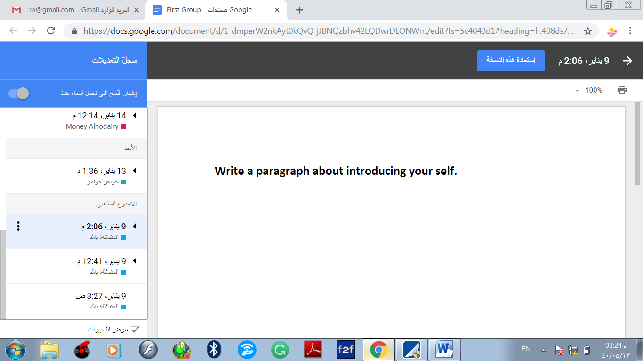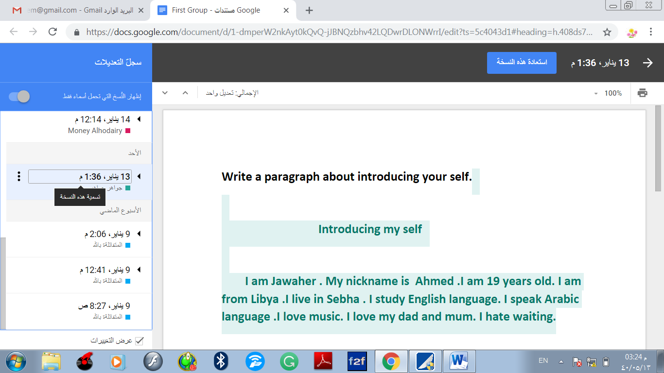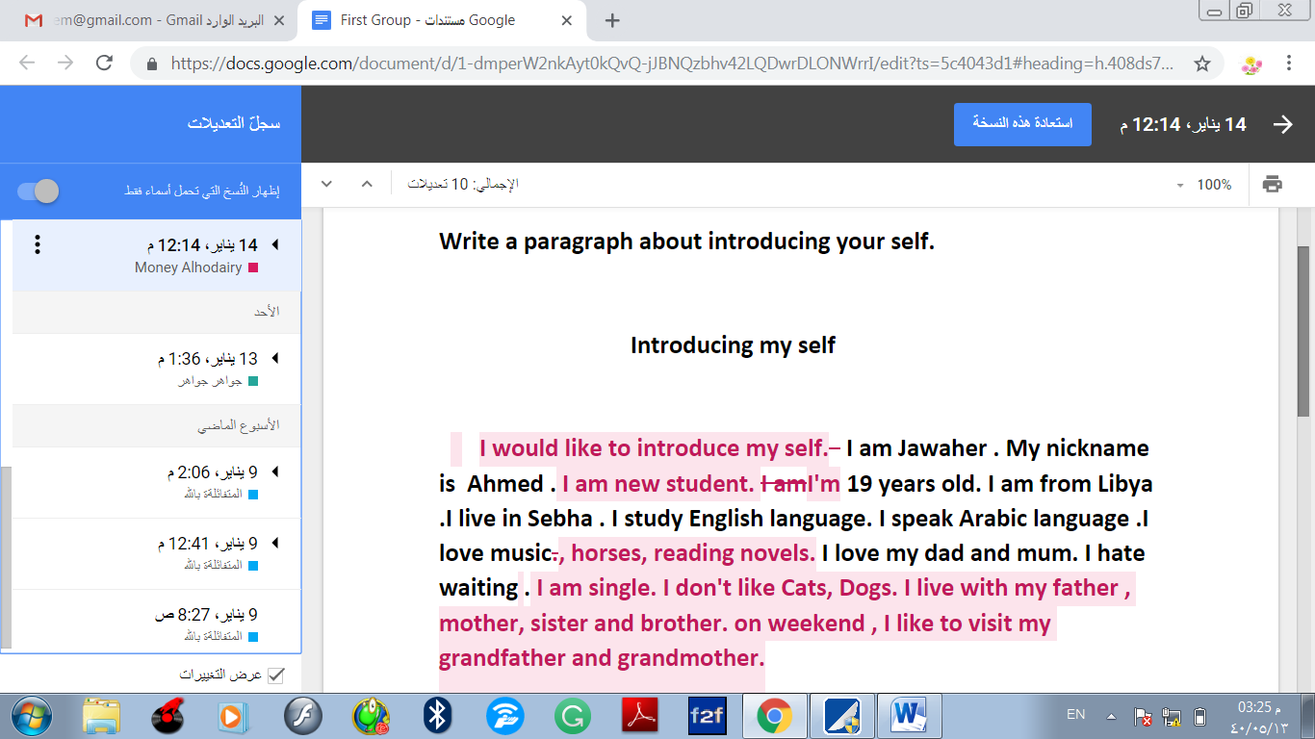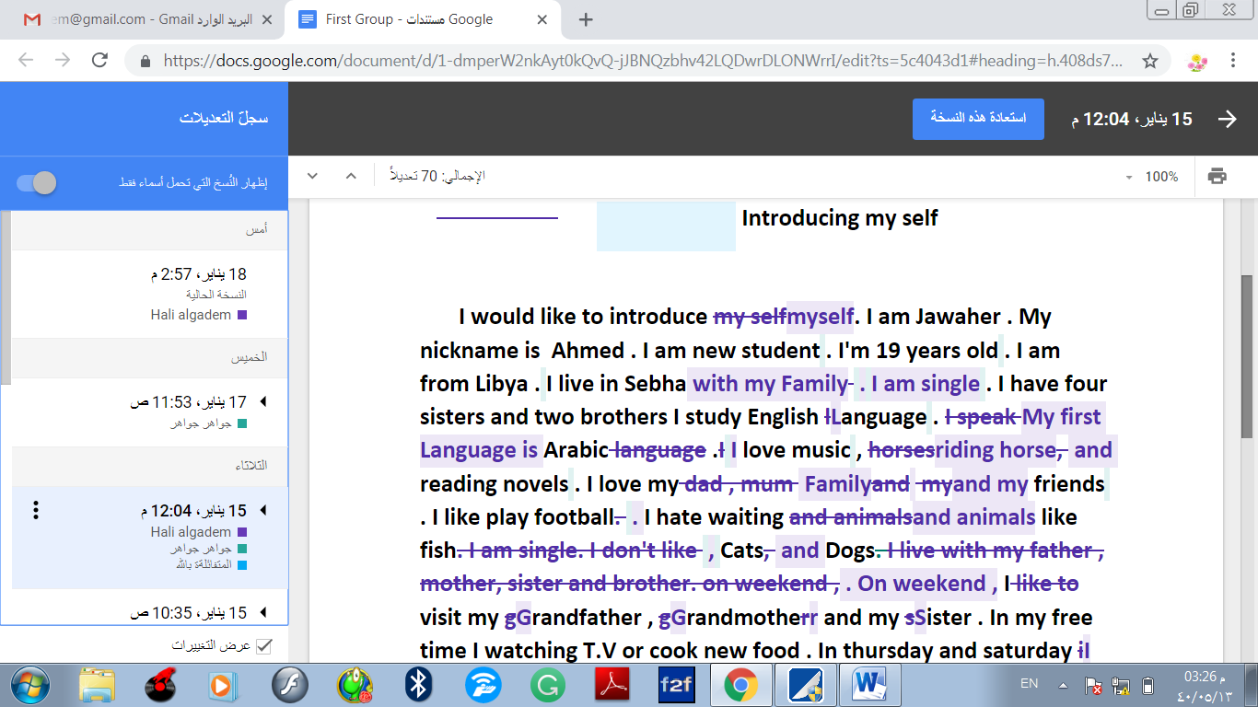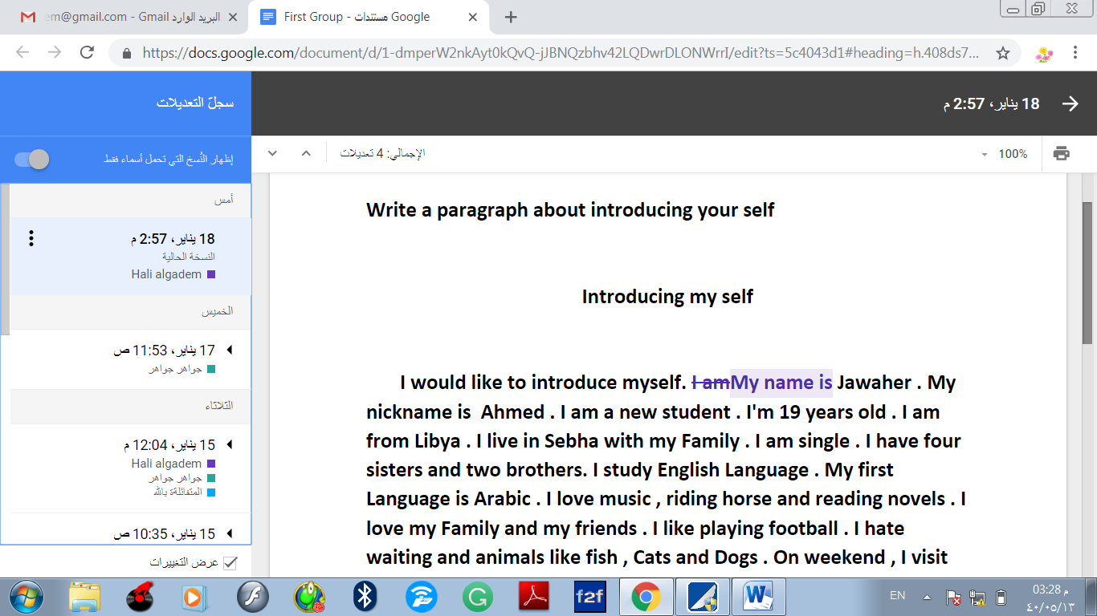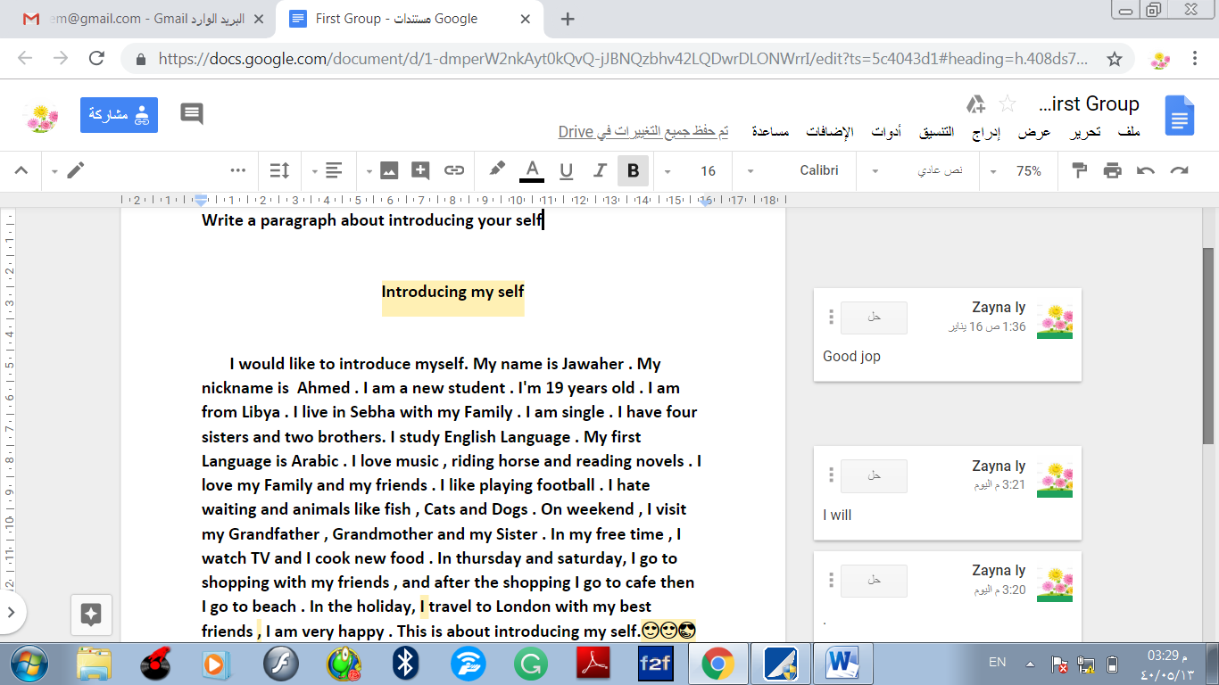
- Second group

